

W

Informatics Institute of Technology

B(Eng) Software Engineering

**Software Development Group Project**

5COSCC021

Module Leader: Mr. Banuka Athuraliya

**Sri Lankan Sign Language Gaming - Learning System -**

**Palmingo**

SE-86

Implementation Report

| Name | IIT Email | UoW ID | IIT ID |
| --- | --- | --- | --- |
| ARUMADURA IMETH AYUKA DE SILVA (LEADER) | imeth.20233163@iit.ac.lk | W2083096 | 20233163 |
| KRITHIGA THACHANAMOORTHY | krithiga.20230037@iit.ac.lk | W2051541 | 20230037 |
| SAFIYA BINTHI MAHIR | safiya.20230788@iit.ac.lk | W2051772 | 20230788 |
| SURAWEERA ARACHCHIGE WUVANSA DULSRIWEE | suraweera.20230440@iit.ac.lk | W2051698 | 20230440 |
| ADNAN RAUFF | adnan.20231287@iit.ac.lk | W2052018 | 20231287 |
| MARAWEERASINGHE DEWAYALAGE DIDULA ARAVINDA | didula.20221154@iit.ac.lk | W1953837 | 20221154 |

# Declaration

We hereby declare that the work presented in this project report is the result of our independent research and efforts. All information and data presented herewith are authentic to the best of our knowledge and any external sources and references are appropriately cited. This report has not been submitted previously for any academic program or certification.

**Full Name :** Arumadura Imeth Ayuka De Silva



**IIT ID | UOW ID :** 20233163 | w20830964

**Signature :**

**Full Name :** Krithiga Thatchanamoorthy

**IIT ID | UOW ID :** 20230037 | w2051541

**Signature :**

**Full Name :** Safiya Binthi Mahir

**IIT ID | UOW ID :** 20230788 | w2051772



**Signature :**

**Full Name :** Suraweera Arachchige Wuvansa Dulsriwee

**IIT ID | UOW ID :** 20230440 | w2051698

**Signature :** 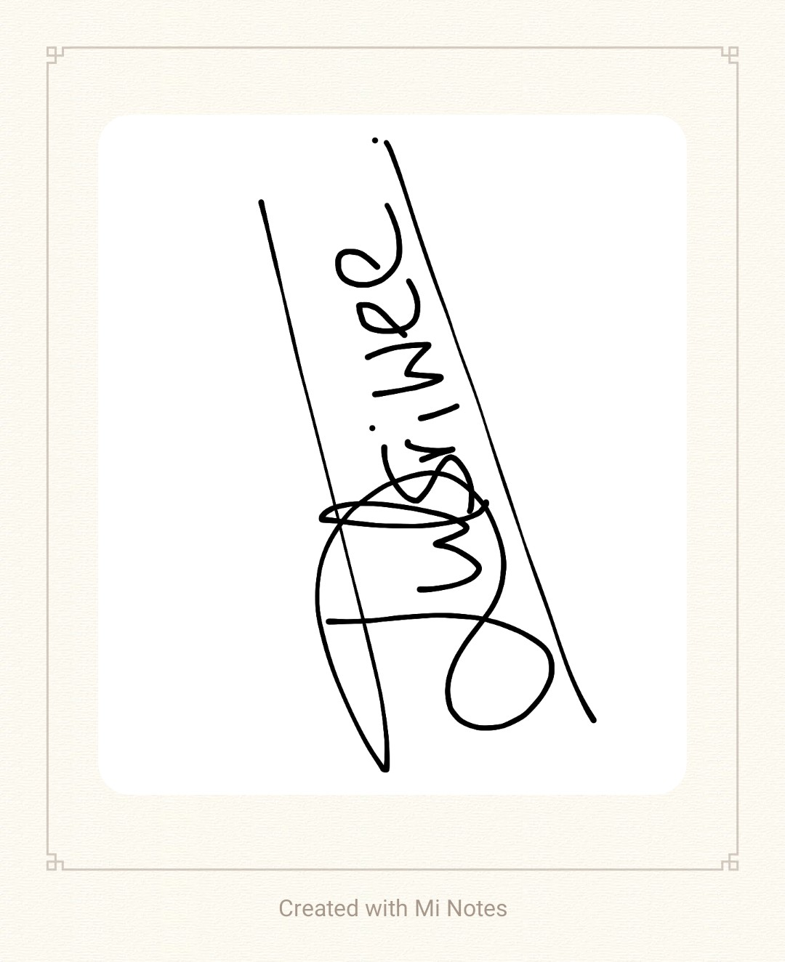

**Full Name :** Adnan Rauff

**IIT ID | UOW ID :** 20231287 | w2052018

**Signature :**

**Full Name :** Maraweerasinghe Dewayalage Didula Aravinda

**IIT ID | UOW ID :** 20221154 | w1953837



**Signature :**

# Abstract

# Acknowledgement

# Table of Content

# List of Figures

# List of Tables

# Abbreviations Table

| **Abbreviation** | **Explanation** |
| --- | --- |
|  |  |
|  |  |
|  |  |
|  |  |
|  |  |
|  |  |
|  |  |
|  |  |
|  |  |
|  |  |
|  |  |
|  |  |
|  |  |
|  |  |
|  |  |
|  |  |
|  |  |
|  |  |
|  |  |
|  |  |
|  |  |
|  |  |
|  |  |
|  |  |
|  |  |
|  |  |
|  |  |

# **CHAPTER 1: IMPLEMENTATION**

## **Chapter Overview**

This chapter provides an overview of the technical aspects of Palmingo, a gamified learning solution for teaching Sri Lankan Sign Language to children with hearing impairments. It covers key technologies, architectural decisions, and the integration of 3D characters, mini-games, and UI design. The chapter highlights data management, user progress tracking, accessibility, deployment pipelines, version control, and CRUD operations. It sets the foundation for exploring the prototype’s features, technology choices, and development strategies, offering insights into how Palmingo enhances sign language learning through gamification.

## **Overview of the prototype**

## A gamified mobile application designed to teach Sri Lankan Sign Language to children with hearing impairments is the implemented prototype. The prototype includes interactive mini-games and engaging learning experiences to reinforce sign language comprehension in a fun and immersive way. Unity was used for game development, ensuring a smooth and visually appealing user experience.

## The prototype features multiple entertaining games as well as educational, including Word Matching, Endless Runner, Flappy Bird Sign-Language, and Dodge the Wrong Word, all designed to enhance learning through gameplay. A 3D animated Fox character named “Nugget”, modeled and rigged in Blender, is integrated into the game to provide interactive guidance and motivation for users. A structured learning page presents sign language lessons in an organized manner, while Game progress is synchronized in real time enables users to monitor their achievements over time.The intuitive UI design allows users to easily navigate between learning modules, games, and progress pages, making the app both accessible and engaging.

## The prototype aims to empower children with hearing impairments by providing an interactive, gamified learning experience, fostering sign language literacy through real-time progress tracking, structured lessons, and immersive gameplay mechanics.

## **Technology selections**

## The technology used in the development of Palmingo was carefully chosen to ensure a stable, engaging, and accessible learning platform for children with hearing impairments. The selection process prioritized cross-platform compatibility, real-time interactivity, and user engagement to create an immersive learning experience.

1. Game Development: Unity

Our team chose Unity as the primary game development engine due to its strong cross-platform compatibility and flexibility in handling interactive 3D environments (Mobile App and Game App Development, 2023). Unity’s powerful rendering engine allowed for the creation of visually engaging sign language learning experiences. Additionally, Unity’s extensive developer community facilitated rapid prototyping and debugging, ensuring the application met accessibility and usability standards (Kim, J., & Kim, H., 2020).

1. 3D Modeling and Animation: Blender

To enhance engagement, a fully interactive 3D fox character was designed, rigged and animated using Blender. This character was then integrated into Unity to guide users through learning activities and gameplay. Blender was chosen due its advanced modelling and animation capabilities, as well as its seamless compatibility with Unity. (Kim, J., & Kim, H. 2020). The use of animated characters added a gamified and immersive element to sign language.

1. Mobile Application Development: Unity UI

The user interface (UI) of the mobile application was developed using Unity’s UI Toolkit. This ensured an intuitive and user-friendly experience. The UI was structured to allow seamless navigation between games, lessons, and progress tracking pages, making it accessible and engaging for children making it an educational application (Wu, C., & Lin, S., 2021). Unity’s UI framework provided customization options that ensured consistency across different screen sizes and devices.

1. Gesture Recognition: MediaPipe (Not Successfully Integrated)

Initially, MediaPipe-was explored to enable gesture recognition for sign language detection. However, despite extensive development efforts, integrating MediaPipe with Unity presented significant challenges As a result, the development focus shifted towards enhancing gameplay mechanics.

## 

## **Implementation of the backend component**

Since Palmingo is built as a standalone Unity application, all game-related data and logic are processed within Unity’s ecosystem. The backend structure primarily consists of:

* Local Data Storage: Player progress, unlocked items, and other game-related information are stored locally using PlayerPrefs and JSON files.
* Game Logic Handling: The backend is responsible for managing interactions between different components, such as gameplay mechanics, user progress tracking, and in-game purchases.
* Event-Driven Architecture: Unity’s C# scripts handle all backend processes through event-driven programming, ensuring smooth and efficient execution.

Local Data Storage

## 

## 

## **Implementation of the front end component**

## At the beginning of the development process, the team considered using Flutter, an open-source framework for building multi-platform applications. Flutter was initially chosen due to its ability to create visually appealing and responsive UIs across different platforms with a single codebase.

Upon discussing these challenges with the supervisor, the team reevaluated their approach and explored the feasibility of developing the entire application within Unity. Through further research, the team identified several advantages of using Unity as the primary framework for frontend development. Following are some of the reasons in favour of Unity (Unity Technologies, 2023) :

*Ease of Use and UI components:*

* Unity provides a user-friendly development environment with built-in UI components such as buttons,text fields, images, and panels, making it easier to design interactive interfaces.
* The Canvas system allows for effortless layout design , reducing the need for complex UI coding.
* Utilizing AI generated assets and free copyrighted icons from platforms like Icons8 streamlines the asset acquisition process, improving both design efficiency and application aesthetics.

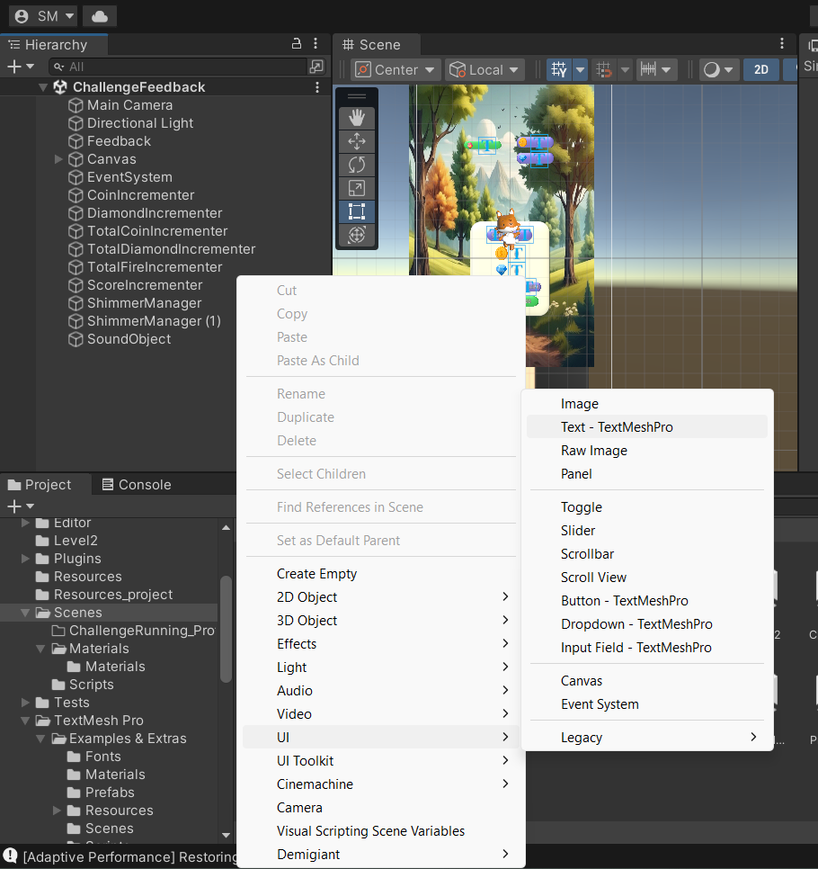

*Adding UI components in Unity*

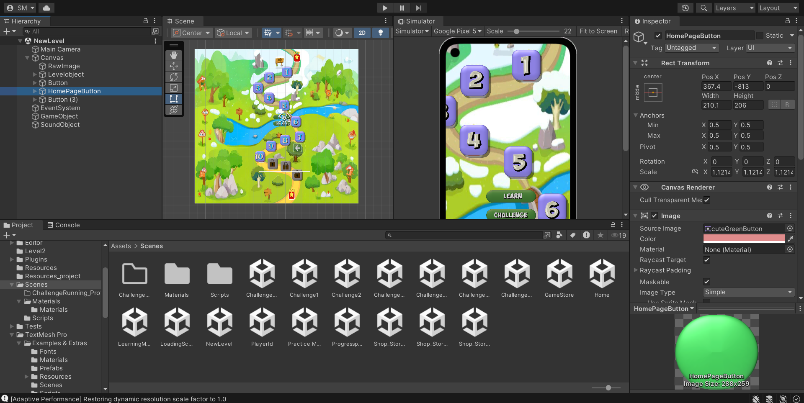

*Unity workspace for UI*

*Page Structure and Navigation:*

* The main pages in Palmingo, such as homepage,learning page,challenge menu,and progress page, share a consistent layout within Unity to ensure a cohesive user experience.
* Each page is represented as a scene with its own Canvas,allowing smooth integration and easy management of UI elements.
* Simple C# scripts are utilized to handle user-specific details, such as progress tracking,animations, and time-based interactions.
* Page transitions are managed efficiently within Unity by loading different scenes,ensuring a smooth and immersive user experience throughout the application.

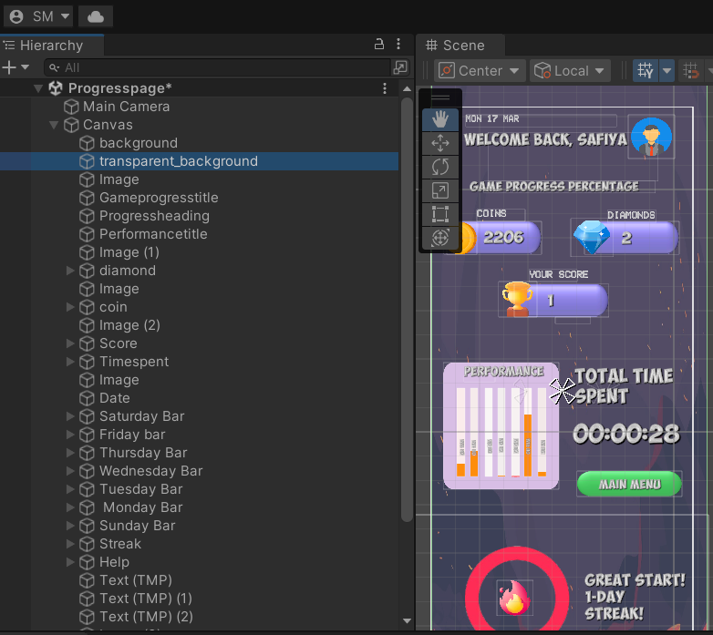

*UI components of ProgressPage Scene*

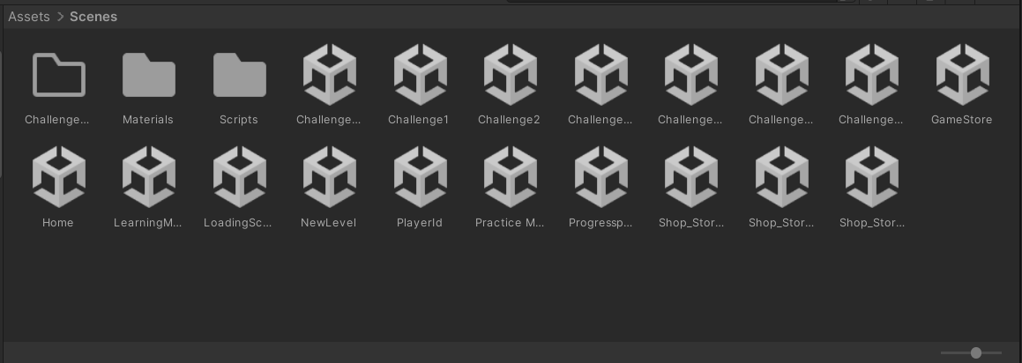

*Scenes with their own functions in the mobile application*

*Game library Interrogation :*

* Unity enables the creation of an interactive game selection system,enhancing user engagement and accessibility.
* In Palmingo, users can effortlessly navigate through different game options, selecting activities, such as the Word Matching Game, Flappy Bird Sign Game, Dodge the Wrong word, and Endless Runner game.
* Each game is presented with a brief description and an intuitive button interaction that allow users to initiate gameplay smoothly
* Progress tracking features are incorporated into the system, ensuring users can monitor their achievements and improvements over time.

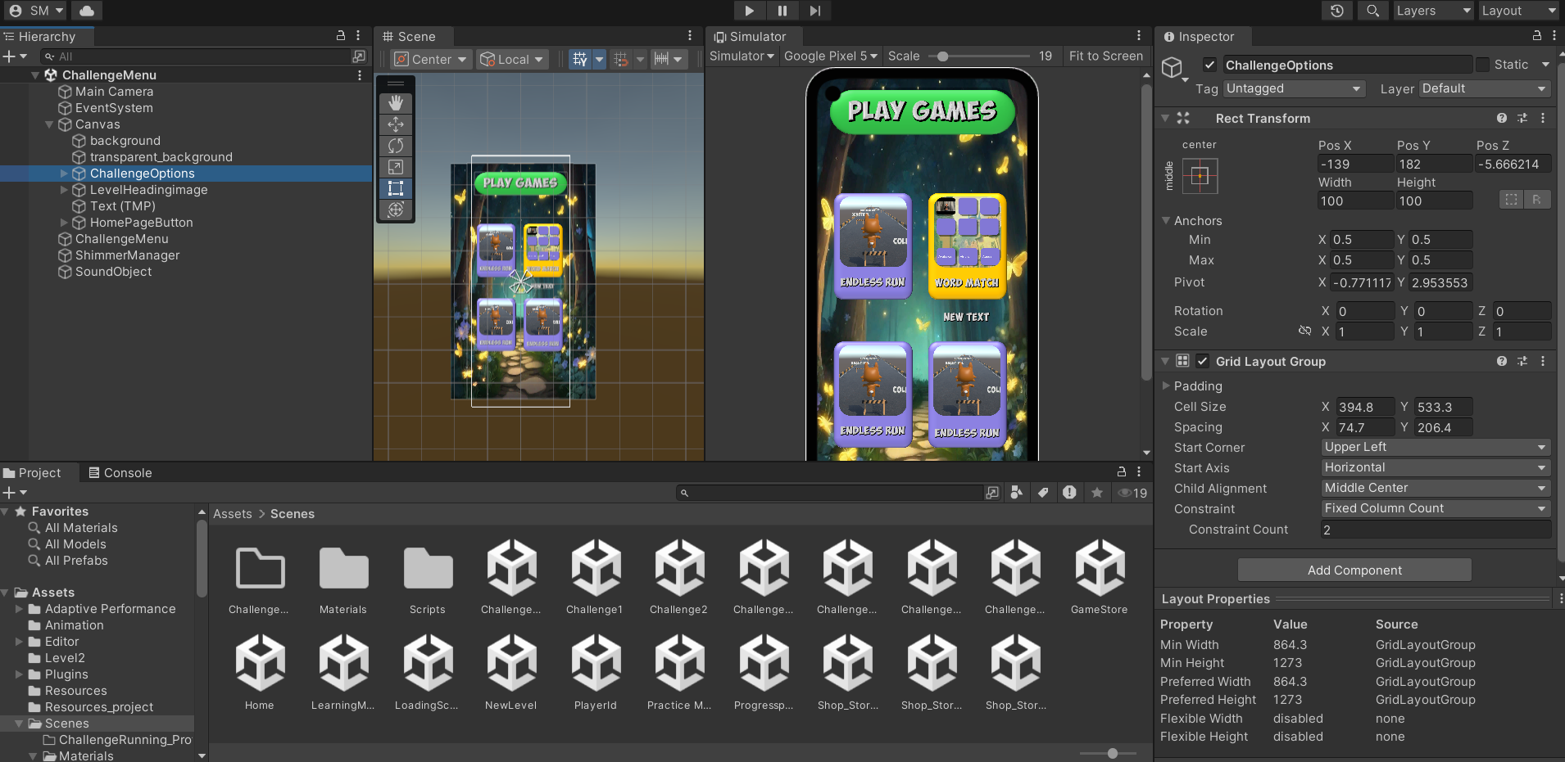

*Game selection interface in Palmingo*

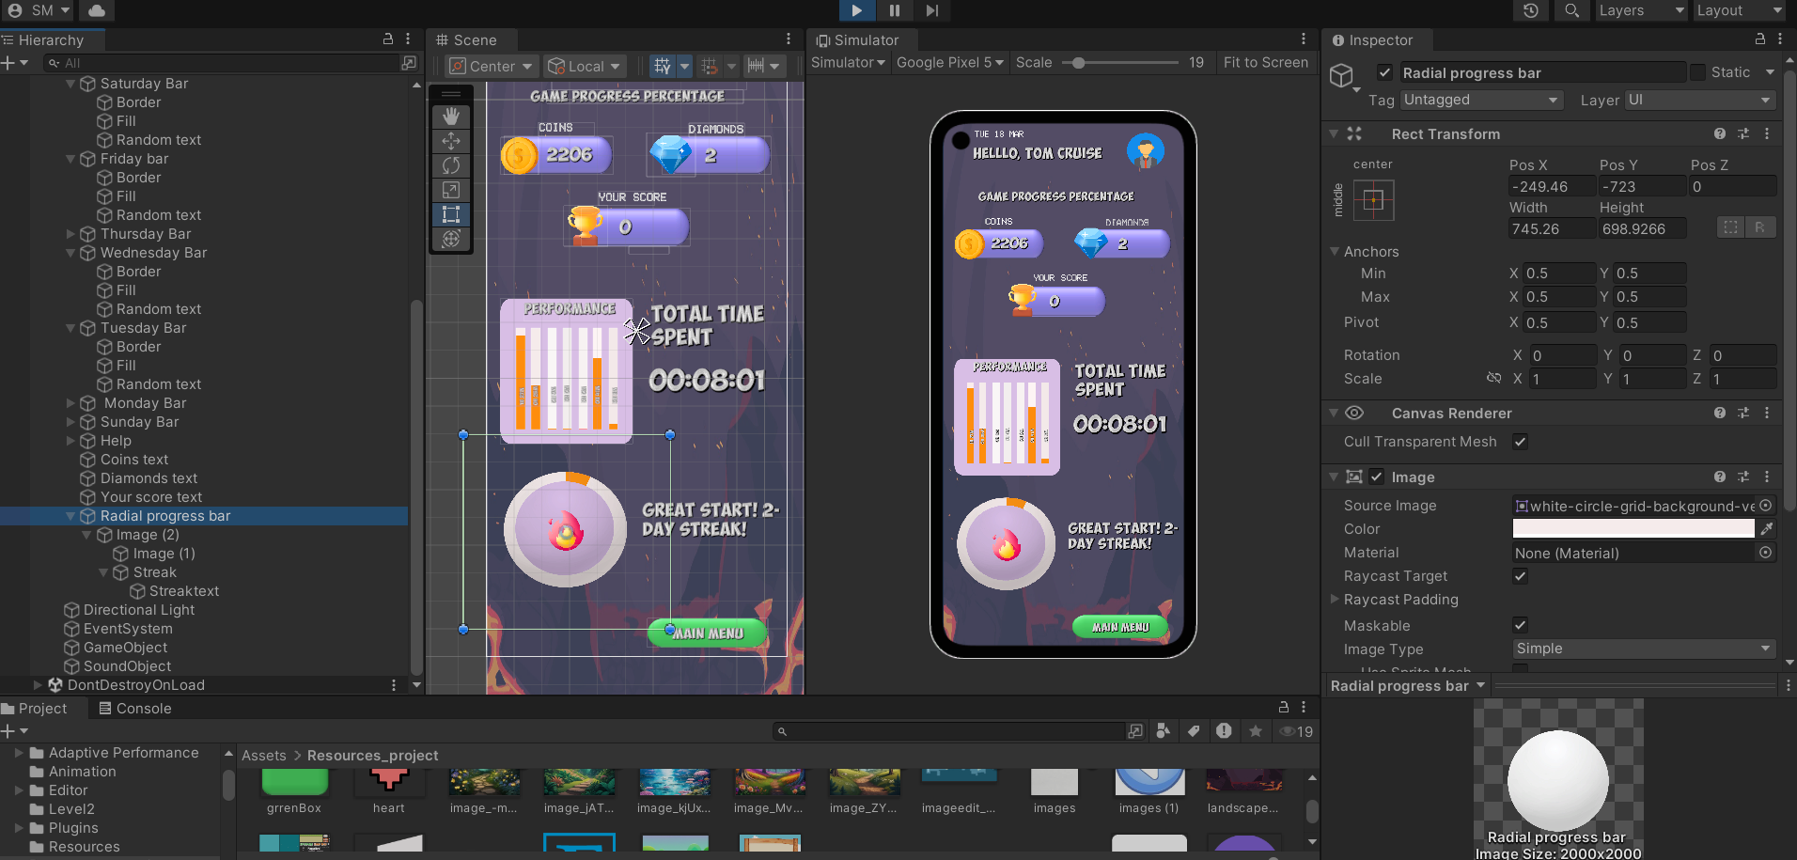

*Radial Bar to show streak progress*

Overall, Unity's robust UI components, structured scene management, and game integration capabilities helped overcome early development challenges, making it the ideal platform for Palmingo’s interactive learning experience.

## **GIT Repository**

Git has become a widely used tool for enabling collaboration - in an industry-wide survey of over 16,000 data scientists conducted by Kaggle, 58.4% of the 16,000 respondents said that Git was the main tool used for sharing code in their workplace (Andrea E. Johnson, 2021). This section outlines the Git workflow used by the development team for managing version control and collaboration in the creation of Palmingo.

### Git and Github Desktop were employed to manage the project’s source code, allowing for a seamless teamwork, and structured collaboration among team members. The repository [**Sign_language**](https://github.com/Krithi757/Sign_language), is hosted on GitHub and is made publicly available for transparency and accessibility. Screenshots related to this section can be accessed at Appendix Section A.1.

### **Branching Strategy**

To facilitate an organized development process, the team adopted a branch strategy that allocates distinct branches for specific tasks assigned to individual developers. The naming conventions for these branches include both the task and the team member’s name, as outlined below.

**PracticeMode/Imeth:** This branch which initially was focused on developing the gesture recognition and practice mode, was then later changed for developing the in-game store.

**Challenge/Krithiga:** This branch was dedicated to tasks related to the implementation of challenge mode features within the application.

**Progress/Safiya:** This branch handles tasks related to progress tracking and achievements within the application.

**LearningPage/Didula:** This branch is reserved for the development of the Learning Mode or features related to lessons and tutorials.

**Challenge/Adnan:** This branch includes work on challenge-based games or related features.

**Challenge/Wuvansa:** This branch includes work on challenge-based games or related features.

When developers plan to perform specific tasks such as bug fixing or feature implementation without affecting the mainstream development, they often create a branch. Then they will work on this new branch independently without interfering with other developers (Weiqin Zou, Weiqiang Zhang, Xin Xia, 2019).

By organizing the development process into task-specific branches, the team ensures that individual developers can work in isolation without interfering with the work of others. This approach minimizes potential conflicts and enables better organization of the development process.

1. **Merge, Push, Pull and Resolving conflicts**

Each team member regularly commits changes to their assigned branches, ensuring that each commit is small and focused. These commits help maintain a clear and organized project history, making it easier to navigate and identify the purpose of each change. After committing locally, changes are pushed to the remote repository on GitHub, ensuring that the most recent updates are accessible to team members. This regular synchronization minimizes the risk of conflicts and ensures that the project remains up-to-date for everyone involved.

To incorporate task-specific changes into the main branch, the team follows a systematic process using pull requests (PRs). Each PR undergoes a review process to ensure quality and stability before merging into the main branch. In cases where merge conflicts arise, the team resolves them through clear communication and careful review, ensuring that all changes are integrated smoothly. This approach helps maintain the integrity of the project and ensures a stable codebase throughout development.

## **Deployments/CI-CD Pipeline**

The deployment pipeline for Palmingo, incorporates Continuous Integration (CI) and Continuous Development (CD) practices. Considering that the project is ultimately developed using Unity, the team utilized Game CI, an automated pipeline tool, to streamline the process of building, testing and deploying the application. This CI/CD pipeline ensures that all changes made to the project are automatically built and deployed to a production environment with minimal manual intervention. Screenshots related to this section can be accessed at Appendix Section A.2.

### **CI/ CD Pipeline Architecture**

GitHub recently introduced GitHub Actions1 (the feature was made available to the public in November 2019). GitHub Actions allow the automation of tasks based on various triggers (e.g., commits, pull requests, issues, comments, etc.) and can be easily shared from one repository to another (Timothy Kinsman, Mairieli Wessel, Marco A. Goresa, Christoph Treude, 2021).

The deployment pipeline is built upon GitHub Actions and Game CI, enabling automation of the entire software delivery process. The pipeline is triggered exclusively by commits and pull requests merged into the main branch. At the end of each successful pipeline execution, a GitHub release is generated, ensuring proper versioning and accessibility of the latest build.

| Stage | Description |
| --- | --- |
| Commit & Push | Workflow is initiated and specified for only pushes and pulls on the main branch. |
| Build Process | Game CI initiates the unity build process for the target platform. |
| Automated tests |  |
| Artifact upload | Successfully built files are uploaded as GitHub artifacts. |
| GitHub Release | A new release is generated with version control for tracking updates. |

By leveraging Game CI within the GitHub Actions Framework, this pipeline enhances the reliability and scalability of the application while maintaining rapid development cycles. Future enhancements may include additional testing frameworks and extended platform support to further optimize the deployment pipeline.

## **CRUD operations**

## The development of the application required a collaborative effort where each team member was responsible for implementing distinct aspects of the system, contributing to both functional and interactive components. The project encompassed game development, user interface design, and backend functionality to ensure a seamless and engaging learning experience.

### **Member 1 (Imeth De Silva)**

Initially Member 1, worked extensively on developing a MediaPipe recognition model for gesture recognition integration into the game. However, due to challenges encountered in integrating the model with Unity, it could not be successfully implemented. As a result, Member 3 shifted focus to the development of in-game store features, which introduced customization options for users, allowing them to unlock new characters and explore additional content. Screenshots related to this section can be accessed at Appendix Section A.3.1.

### **Member 2 (Krithiga Thachanamoorthy)**

Member 2 was responsible for the modelling, rigging and animating a fully interactive Fox 3D character using Blender, which was later integrated to Unity. Additionally, Member 2 developed two major gameplay features. The Word Matching Game challenges users to match words with their corresponding sign language gestures, while the Endless Runner Game reinforces learned concepts through an engaging gameplay format.

Member 2 also focused on the design and implementation of pages that enhance user experience and ensure smooth navigation. These pages include, the home page, loading page, level page, player Id page, challenge menu page and challenge feedback page. Screenshots related to this section can be accessed at Appendix Section A.3.2.

### **Member 3 (Safiya Mahir)**

Member 3 was responsible for the implementation of a structured Progress Page, which enables users to track their learning milestones and provides visualized achievements to motivate continued progress. Screenshots related to this section can be accessed at Appendix Section A.3.3.

### **Member 4 (Didula Aravinda)**

Member 4 was responsible for designing and implementing the learning page which was designed to offer structured learning lessons, ensuring that educational content is presented in an organized and an interactive manner. Screenshots related to this section can be accessed at Appendix Section A.3.4.

### **Member 5 (Adnan Rauff)**

Member 5 developed a Flappy BIrd Game as part of the application’s interactive gaming aspects. As players navigate through the obstacles, they must ensure the bird passes through the correct sign-language-word associations displayed along the pipeline. The game combines traditional Flappy Bird mechanics with a sign language educational element. Screenshots related to this section can be accessed at Appendix Section A.3.5.

### **Member 6 (Wuvansa Suraweera)**

Member 6 focused on the creation of the "Dodge the Wrong Word" game, which was designed to challenge users in selecting the correct sign-language-word associations while avoiding incorrect ones. Screenshots related to this section can be accessed at Appendix Section A.3.6.

### 

## 

## 

# 

# **CHAPTER 2: TESTING**

## **Chapter Overview**

This chapter focuses on the testing phase of Palmingo, ensuring that the system meets all its functional and non-functional requirements. The chapter begins by outlining the goals and objectives of testing, followed by a discussion on the testing criteria used. The chapter then delves into testing functional and non-functional requirements ensuring that all system components operate as intended under different conditions. Key testing methodologies such as unit testing, performance testing, usability testing, compatibility testing are supported with proper screenshots and justifications. Finally, the chapter concludes with an analysis of limitations faced during testing and a critical evaluation of the testing process.

## **Testing Criteria**

The purpose of the ISO/IEC/IEEE 29119 series of software testing standards is to define an internationally agreed set of standards for software testing that can be used by any organization when performing any form of software testing (ISO/IEC/IEEE 29119, 2013). The testing criteria for Palmingo will be defined using a risk based testing (RBT) approach, in line with the ISO/IEC/IEEE 29119 testing standards. Risk analysis will be performed to identify and prioritize potential risks associated with the game’s functionality, performance and user experience.

Game testing ensures that a game functions properly and provides a smooth experience for players. It helps identify and fix bugs, optimize performance, and improve the overall gameplay experience before release (Doruk Giray, 2024). This test approach will guide the creation of test cases, covering both functional and non-functional requirements, and will focus on core areas such as player engagement metrics, gameplay performance, device compatibility and data security.

## **Goals of Testing**

In the gaming industry, the first impression is of utmost importance. Thus, like with any piece of software to deliver high-quality games, game developers must test their games rigorously during their development (Cristiano Politowski, Fabio Petrillo, Yann-Gael Gu ¨ eh´ eneuc, 2021).

The goal of testing Palmingo is to ensure the application delivers a reliable, engaging and educational experience for children learning sign language. The testing will focus on verifying the functionality, accuracy and performance of the application while ensuring it meets user expectations. Goals of testing Palmingo is as follows:

* Ensure core functionality and validate the application’s usability and engagement for children.
* Test performance under different load conditions to ensure scalability.
* Verify compatibility across various devices and OS.
* Redefine the application to include improvements from test results.

## **Testing functional requirements**

| Test case no | Feature tested | Test case description | Test case condition | Expected result | Actual result | Status |
| --- | --- | --- | --- | --- | --- | --- |
| 1.0 | FR1: Learning Mode | User selects a learning category | User chooses a level to start learning | Level should load and user should see learning video and caption | Level loaded, and learning video played with caption | Pass |
| 2.0 | FR2: Challenge Mode | User chooses a challenge from the challenge menu | User starts the mini challenge to earn coins and diamonds | Game should load and user should be able to play | Game loads and player is able to play seamlessly without any lags | Pass |
| 3.0 | FR3: Progress Tracking | Test tracking of user progress when it comes to learning, playing and practicing | Display of charts based on user performance | User progress should be updated and displayed | Progress updated and displayed | Pass |
| 4.0 | FR4: Reward System | Reward system validation | Verify that rewards increase for correct answers and decrease for incorrect answers | Rewards should be updated correctly based on user performance | Rewards are correctly updated based in user performance | Pass |
| 5.0 | FR5: Level page | Level based restriction | Ensure users can only access content from selected levels | Users should be able to only access from the selected levels | Users are able to only access from the selected levels | Pass |
| 6.0 | FR6: Challenge Mode | Challenge mode flexibility | Ensure users can choose from a variety of challenges according to their desire | Users should be able to select a desired challenge from a challenge menu | Users are able to select a desired challenge from a challenge menu | Pass |
| 7.0 | FR7: Settings | Adjust audio/ sound effect controls | Test if users can adjust sound controls | Users should be able to able/disable music, sound effects separately or together | Users are able to able/disable music, sound effects separately or together | Pass |
| 8.0 | FR8: Scene transitions | Seamless scene transition | Test if user can go back to home page and go to the next scenes seamlessly | Users should be able to transition to the main menu when needed | Users are able to transition to the main menu when needed | Pass |

## **Testing non-functional requirements**

The non-functional requirements of Palmingo are detailed in Section while testing was conducted to evaluate the system’s accuracy, performance, memory consumption and timing constraints. The system's performance was evaluated to ensure smooth gameplay across various devices, verifying its responsiveness under different load conditions.

CPU and memory usage were carefully monitored to maintain efficiency, minimizing battery drain and preventing lag during extended use. Frame rate analysis was performed to ensure consistent rendering at the target FPS, providing fluid animations and seamless transitions among different modes within the game such as learning, gaming and practicing.

Timing tests focused on reduced latency, ensuring real-time responsiveness throughout gameplay and user interactions. These evaluations ensure that Palmingo delivers a stable and a responsive and enjoyable user experience.

The evaluations conducted ensure that the application provides a robust, user-friendly, and secure experience across a wide range of conditions.

**NFR1 - Reliability -** Tests were conducted to verify the system's stability, uptime, and error-handling capabilities. The goal was to ensure that Palmingo operates without unexpected crashes or data corruptions and can gracefully recover from any unforeseen errors.

**NFR2 - Usability -** Usability testing focused on the user experience, ensuring that the system is very intuitive, easy to navigate and accessible to users of various ages and backgrounds. Feedback was collected from the Central Federation of the Deaf and The School of the Deaf, Ratmalana to evaluate ease of use, functionality and overall usability.

**NFR3 - Scalability -** While Palmingo operates efficiently with the tested user base, plans are in place to accommodate future growth. To handle an increasing number of users and larger content volumes, Firebase will be integrated as the database solution. This will enable the application to scale ensuring that performance and storage are maintained as user demand grows.

**NFR4 - Performance -** Performance testing was carried out to evaluate the system’s efficiency under various conditions. This included testing memory consumption, CPU usage, and response time to ensure smooth and uninterrupted gameplay. Performance was tested across a variety of devices to ensure that Palmingo remains responsive, efficient and stable regardless of device specifications.

**NFR5 - Security** - Security testing has not been conducted in the current phase of development. However, future iterations of Palingo will prioritize securing user data and ensuring safe access to the application. Plans include integrating Firebase for user authentication and secure data storage to prevent unauthorized access and protect user privacy as the application scales.

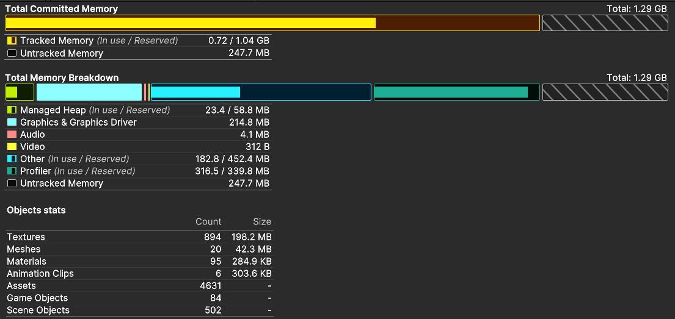

Total Memory Usage Testing

Figure illustrates the Total Memory Usage Testing results for Palmingo, captured and analyzed using Unity’s Profiler and Memory Profiler Tools. These metrics were essential for assessing how efficiently the game utilizes system resources, ensuring optimal performance across a wide range of devices. These metrics provide valuable insights into how the game utilizes system memory during various gameplay scenarios, ensuring efficient resource management and smooth user experiences across different devices.

**Unity Memory Metrics Breakdown:**

**Total Committed memory:** This metric represents the total memory allocated by the Unity engine for the application, encompassing both tracked and untracked memory. Monitoring this value was crucial to ensure that Palmingo did not exceed device memory limitations.

**Total tracked memory:** Tracked memory refers to memory usage that unity manages and monitors including assets such as mesh, textures, audio files and scripts.

**Untracked memory:** Untracked memory refers to memory allocations not directly managed by Unity, often originating from external plugins, drivers or system level processors.

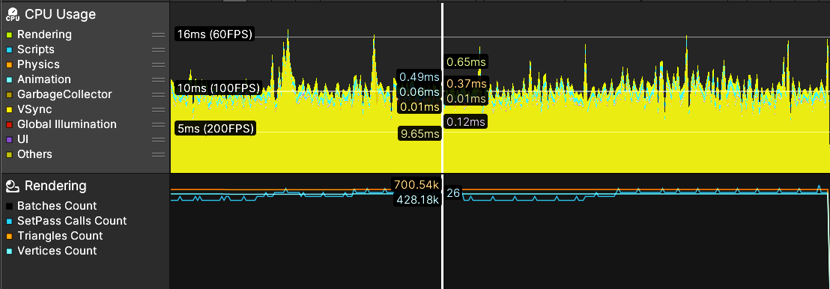

CPU Usage and Performance Testing

Figure illustrates Palmingo’s CPU usage across key processes, including rendering, script execution, garbage collection (GC), animation and UI rendering. Monitoring CPU performance was essential to ensure responsive gameplay, prevent overheating and optimize battery consumption across devices.

Rendering: Rendering was one of the primary contributors to CPU usage, especially given Palmingo’s mix of 2D backgrounds and selective 3D elements. The Unity’s Profiler Rendering provided insights into:

* Draw calls: The number of draw calls was minimized using techniques like static batching, dynamic batching, and GPU instancing.
* Overdraw Reduction: Transparent UI elements and overlapping sprites were optimized to reduce overdraw, which can strain the CPU and GPU.
* Shader Optimization: Simple and mobile-friendly shaders were implemented to speed up rendering processes.

Scripts: Script execution time, captured under the Scripts section of Unity’s CPU Profiler, focused on how efficiently MonoBehaviour methods (Update, FixedUpdate, LateUpdate) ran during gameplay. The following were optimized:

* Reduced Expensive calls: Frequent calls like Find(), GetComponent(), and Instantiate() were minimized or cached.
* Loop Optimizations: Nested loops were reduced, and unnecessary code within frame-based methods was eliminated.
* Coroutines & Event Systems: Heavy tasks were moved to coroutines or handled via Unity’s event system to avoid blocking the main thread.

Garbage Collection: Excessive garbage collection can cause noticeable stutters. GC spikes were monitored under the Garbage Collection section, with steps taken to minimize allocation per frame.

## **Unit testing**

Unit testing is done by writing small test cases that exercise specific behaviors of the code. Tests can be run on individual scripts, GameObjects, or specific features of the game (Unity).

Unit testing was conducted to ensure that the individual components of Palmingo function as expected. An example of manual unit testing in Unity would be adding a test condition for a function and using Debug.Log to output the criteria for it passing or failing (the output of the test scenarios) using Unity’s Play mode (Unity).

The tests were focused on verifying the correctness of methods and functions, ensuring that transitions between game modes, learning mode and progress viewing are working properly. Any issues identified during tests were resolved promptly. Screenshots of the unit test results are attached in Section.

## **Performance testing**

Performance testing was conducted to assess how Palmingo performs under various conditions and ensure smooth gameplay and responsiveness. The primary focus was on evaluating the system’s ability to maintain consistent frame rates, quick load times and minimal lag, especially during transitions between different game modes like learning and gaming. The game was tested on multiple devices, including two Samsung Android devices belonging to different android models and versions, to simulate a real world usage and ensure optimal performance across different hardware configurations.

Testing was also focused on ensuring real-time responsiveness, verifying that user inputs and in-game actions trigger immediate responses without delay. Screenshots of the performance test results are attached in the Appendix Section.

## **Usability testing**

Game User Research (GUR) is the research field that focuses on usability and user experience (UX). Different than QA and technical game testing, GUR methods focus on evaluating players by observing them interact with the game (Cristiano Politowski, Fabio Petrillo, Yann-Gael Gu ¨ eh´ eneuc, 2022).

Usability testing was carried out to ensure that palmingo provides an intuitive and user-friendly experience for all users. The testing focused on evaluating how easy it is for users to navigate through the game, access different modes and interact with various features. Special attention was given to making the game accessible to users of all ages and backgrounds, ensuring that the interface is simple and engaging. Feedback was collected from key groups, including the Central Federation of the Deaf and The School of the Deaf, Ratmalana, to understand their experience with the game’s design and functionality. Screenshots of the usability testing are attached in the Appendix Section.

## **Compatibility testing**

Compatibility testing for Palmingo was conducted to ensure that the game functions smoothly across a wide variety of devices and operating systems. The testing focused on verifying the game’s performance on various android and ios phones. Compatibility with operating systems, such as Android versions 9 through 12. Currently, only the Android APK has been developed, with plans to create an iOS version in the future. Screenshots of compatibility testing across devices are included in Appendix Section Z.

# **CHAPTER 3: EVALUATION**

## **Chapter Overview**

This chapter discusses the crucial role evaluation plays in assessing the effectiveness, usability and overall impact of Palmingo, which aims to bridge the gap of Sri Lankan Sign Language education through a gamified approach. This evaluation aims to determine how well the application meets its objectives, focusing on user engagement, system performance and accessibility for individuals with an interest to use Sri Lankan Sign Language. This section will detail the evaluation methods, present key findings and discuss their implications for future development of Palmingo.

## **Evaluation Methods**

The evaluation process consists of both quantitative and qualitative methods including surveys, expert reviews and performance analysis. By gathering and analyzing feedback from various and diverse user groups and stakeholders, including sign language experts, educators, hearing-impaired community, speech therapists; the study provides valuable insights into the application’s strengths and areas for improvement.

The evaluation methods used in shaping Palmingo included a few quantitative evaluation methods as well as few qualitative methods. In shaping the application, the main quantitative method that was used was the means of a survey, which was sent prior to the development of the application in order to get insights of the customer segment and an evaluation on the features and methods to be implemented. Further, an interview; in particular with the Principal of the Ratmalana School for the Deaf, an interview with a Sri Lankan Sign Language expert in the Sri Lanka Central Federation for the deaf, an interview with senior speech therapists and an analysis from the perspective of a child psychiatric was used to identify the evaluation aspects in order to shape the application.

## **Quantitative Evaluation**

### **Survey**

A survey was carried out from the general public and audience in order to gather their valuable feedback and opinions with regards to the key features and elements of the application. The key findings are presented below:

1. **Familiarity of the audience with Sri Lankan Sign Language**

85% of the respondents were found out to be complete beginners in SSL while only 11.3% had basic knowledge with regards to the language. This showcases the demand for the application.

1. **Application interest and enjoyment**

42% of the audience believed that learning SSL would be fun and beneficial and the majority felt it would be engaging particularly for the children if gamification elements were included. 25% of the respondents rated their excitement level between 8-10 indicating strong interest in gamified learning approaches.

1. **Game Features**

Close to 50% of the participants felt that game elements such as puzzle solving, level based games and quick reflexes challenges should be prioritized. Furthermore they also voted that animated characters would improve the fun and visual aspects of the application. Daily challenges were rated as an effective element to keep children engaged long-term. 31% of the participants considered the gesture recognition feature to be essential with 56% mentioning concerns about the children’s frustration with possible accuracy issues. 58% of the respondents considered the progress tracking feature to be an excellent idea to keep the interest and engagement levels on a good level for the application.

## **Qualitative Evaluation (Feedback from end users, domain experts and**

## **3.4.1 Sign Language Interpreter from the Sri Lanka Central Federation for the Deaf**

As part of the evaluation process in developing Palmingo, a meeting was held with a leading sign interpreter in the SLCFD. Crucial feedback was gained in shaping the application to suit the needs of the deaf community. The key findings are presented below.

1. It was identified that many families without a hearing-impaired background create their own informal sign systems, causing learning disparities.
2. Colombo, Kurunegala, Jaffna, Kilinochchi, Gampaha were identified as the geographical areas with a high hearing-impaired population, while Nuwara Eliya in particular lacked the most in terms of SSL resources.
3. A child typically takes about two years to master SSL while attending school, with limited support in education which results in roughly only 100 students passing O/Ls yearly and very few entering universities.
4. As there are no known gaming apps for SSL, but some exist for text to sign language translation; the federation supports the idea of a gamified learning app.
5. It was recommended that the SSL alphabet be included as it covers about 25% of the fundamentals; followed by Opposite words, colors, nouns and verbs and such.

With these key points highlighted, the Central Federation of the Deaf also offered their support and willingness to endorse the app and introduce it to the hearing-impaired schools registered under them.

## **3.4.2 Principal of the School for the Deaf Ratmalana**

An in-person meeting was held with the Principal of the School for the Deaf Ratmalana, Mrs. Anusha Fernando, with the objective being to gather information on the current existing resources and learning methods for SSL and to get the perspective from a teacher’s point of view on how best to approach teaching sign language and to get feedback on the effectiveness of the application. The following key points were identified;

1. Smartboards and visual aids and whiteboards are used as the main sources in teaching, with the digital tools being limited. It was identified that visual aids are one of the main methods of communicating with the hearing-impaired children.
2. Economic barriers where students lacked access to smartphones and internet access.
3. The gamification approach was encouraged as it can boost motivation, but needs careful balance to prevent distractions. It was suggested maybe the game can align with the school syllabus to be effective.
4. With regards to the gesture recognition, it was mentioned it was not that necessary for deaf students as even students in grade 1 are typically fluent in SSL. But it was mentioned it might be more useful for hearing individuals trying to learn SSL from the start.
5. Family engagement features are valuable as it improves communication at home.

## **3.4.3 Evaluation meeting with Senior Speech Therapists**

Following the development process of Palmingo, a meeting was arranged with two Senior Speech therapists; Mrs. Nayanalie Dassanayake, Mrs. Samantha Van Eyk and Behavior Analyst and Skill Development Specialist, Mrs. Ishanthi Perera. This meeting provided valuable feedback in order to improve the functionalities and identify the improvement areas of the application.

One of the key findings identified from the meeting was to follow a standard hierarchical structure when developing the application on a level-basis For example, it was suggested to start with the Sri Lankan Sign Language alphabet; followed by nouns and family names and verbs and such. It was suggested to follow the hierarchical structure mentioned in the Sign language dictionary approved by the Central Federation for the Deaf.

With the above point being one of the key identifications, certain suggestions were also given to improve the gaming parts of the application. The feedback on the gamified approach was very positive as a child is able to retain more information and memory if studying methods are applied through a game with live feedback given. It was suggested that a few pre tests and post tests can be carried out in order to measure the effectiveness of the application. They also suggested that a gesture recognition feature if implemented in the future will improve the usability of Palmingo.

## **3.4.4 Evaluation meeting with a Child & Adolescent Psychiatrist**

Following the meeting with the Senior Speech therapists, a meeting was also arranged with Professor Miyuru Chandrsena, Child & Adolescent Psychiatrist, Professor and Head of the Department of Psychiatry at the University of Kelaniya, Sri Lanka. His expert insights were invaluable as Palmingo’s learning approach was evaluated ensuring it supports the diverse learning needs in children.

Prof. Miyuru highlighted the VARK framework when analysing the effectiveness of Palmingo. The VARK framework is a learning model which stands for Visual, Auditory, Reading/Writing, Kinesthetic). He went on to highlight how the app fulfills three of the four key points in the VARK model and gave important suggestions on how to apply Kinesthetic learning approaches to the game for future development.

He also highlighted Bloom's Taxonomy, which describes levels of learning: Remember, Understand, Apply, Analyze, Evaluate and Create. An emphasis was made on focusing on the Apply level through Problem-Based Learning (PBL) which encourages users and learners to engage in real-world problem solving, case studies and simulations in order to deepen their understanding and skills.

## **Self Evaluation**

*“Palmingo addresses the gap and lack of education resources particularly in the field of teaching Sri Lankan Sign Language. The prototype addresses the main problem domain and brings a gamification approach as a learning method to teach SSL effectively and in a fun manner. From the research, meetings and studies carried out and conducted, the importance of the application was understood with a key focus set on three features, namely the Learning Mode, Practice Mode and Challenge Mode. The Practice Mode originally was planned to be implemented through a Gesture Recognition model able to identify Sri Lankan Sign Language gestures. While not being one of the key features of the application, due to time constraints and complexity levels the feature could not be implemented. As a replacement the focus was set on improving the gaming aspects of the application with a shop store being introduced.*

*The implementation of the application was carried out after a careful study and consideration of the tools and techniques. Palmingo seems to be functioning as expected, while addressing key learning approaches. The overall performance and scope of the application is very satisfactory.”*

Imeth De Silva

*“Lorem ipsum”*

Krithiga Thatchanamoorthy

*“A key aspect of Palmingo’s development was ensuring an engaging and interactive gaming experience to support SSL learning. The focus was placed on developing animated characters, designing interactive mini-games, and constructing various game scenes to enhance the overall user experience. The animated guide, which is a 3D fox model built using Blender, was carefully built to provide a visually engaging assistant, helping users understand and learn SSL more effectively.*

*The Endless Runner game and Word Match game were developed as core gameplay elements, designed to reinforce learning through fun and immersive mechanics. These mini-games were structured to encourage active participation, helping users retain knowledge while maintaining engagement. In addition to game development, efforts were directed toward building various scenes to establish a cohesive and well-structured gaming environment.*

*The overall functionality and scope of the contributions made are highly satisfactory, laying a strong foundation for further enhancements.”*

Safiya Mahir

*“Lorem ipsum”*

Didula Aravinda

*“Lorem ipsum”*

Adnan Rauff

## **Summary**

This chapter evaluates the effectiveness, usability and impact of Palmingo, a gamified Sri Lankan Sign Language (SSL) learning application. A combination of quantitative and qualitative evaluation methods were used, including surveys, expert and user reviews and performance analysis. The quantitative evaluation was primarily based on a survey conducted prior to the development process in order to access user interest and identify key features. The results indicated a strong demand for SSL education as there were many lack of resources particular in terms of software in the field. The qualitative evaluation involved expert insights from sign language professionals, educators, senior speech therapists and child psychiatrists. Key development features, requirements and enhancements were identified through these meetings and evaluation processes which was invaluable to the improvement of Palmingo. The self evaluation from the team members concluded that Palmingo successfully addresses the gap in SSL education through a structured learning approach.

# **CHAPTER 4: CONCLUSION**

## **Chapter Overview**

This chapter provides a brief overview of the achievements, aims, and objectives of the “Palmingo” project. It also highlights the limitations of the research, the rationale behind these limitations, suggestions for future enhancements, and any additional work, such as participation in competitions and research papers. Finally, the chapter concludes with some final remarks.

## **Achievements of Aims and Objectives**

The aim of this project was to create an interactive, gamified mobile application that teaches young students, particularly those with hearing impairments, Sri Lankan Sign Language (SSL). The successful completion of this project can be attributed to the following key achievements that align with the objectives outlined in CW 1- Design and Documentation:

1. **Human-Centered Design**

The application was designed to be accessible and engaging for young learners, especially those with hearing impairments. It features an intuitive interface with animated characters and interactive elements to captivate children’s attention.

1. **Interactive Learning Features**

The app includes interactive quizzes, Q&A sessions, and games that promote active learning and retention, with challenges and rewards to motivate students.

1. **SSL Language Integration**

SSL signs are integrated through animated guides and interactive demonstrations, allowing children to learn and practice at their own pace.

1. **Inclusive Learning Environment**

The app provides easy access to SSL resources, helping hearing-impaired children overcome communication barriers and fostering inclusivity in education.

1. **Technological Innovation for Educational Advancement**

By combining mobile technology with SSL learning, the app introduces innovative and accessible educational tools for disabilities.

1. **Meeting the Immediate Needs of the Community**

The app addresses the need for reliable SSL resources in Sri Lanka, providing a scalable solution to improve accessibility and education for children with hearing impairments.

Overall, the Palmingo application successfully meets the project’s objectives, offering and interactive, inclusive learning experience for young students, especially those with hearing impairments.

## **Limitations of the Research**

One significant limitation was time constraints, which led to scaling down certain features. For example, advanced game modes and personalized learning paths, which were part of the initial plan, couldn’t be developed or tested within the available time frame. Additionally, resource limitations affected the project’s depth, particularly in terms of access to comprehensive SSL datasets and expert guidance, which impacted the accuracy and diversity of the signs represented in the application. Device compatibility was another challenge, while the app was designed for mobile platforms, testing was limited to a limited subset of devices, which restricted the ability to optimize it fully for different screen sizes and operating systems.

Furthermore, the user testing phase was conducted with a smaller size, which limited the feedback obtained regarding usability and engagement. Finally, some advanced technical features, like real-time gesture recognition, were not fully integrated. While the focus was on gamification and SSL learning, more complex features were beyond the scope of the current project. Despite these limitations, the project still provides a solid foundation for future development and improvement.

## **Future Enhancements**

Future enhancements of this project focus on expanding the app’s features and improving it’s overall functionality. One key enhancement would be the addition of more enhanced SSL content, such as a wider range of signs, phrases and regional variations, to ensure a more comprehensive learning experience. Integrating real-time gesture recognition is another planned feature, enabling users to receive immediate feedback on their sign language practice, offering a more interactive and personalized experience.

In terms of improving user experience, more extensive user testing with a diverse group of hearing-impaired children, educators and parents would help refine the interface and content.

Another potential enhancement is the inclusion of multilingual support, enabling the app to accommodate users who speak different languages or dialects in SriLankan Sign Language. Finally, forming collaboration with educational institutions and experts could help develop more scientifically validated learning methodologies, further improving the app’s values.

## **Extra Work (Competitions, Research Paper)**

During the SDGP period, the team actively participated in competitions and hackathons to explore innovative solutions and gain industry exposure.

As part of the Travel Tech Hackathon, the team developed GuideMyHike, a mobile application designed to assist hikers and guides to seamlessly connect with each other and navigate hiking trails with AI powered recommendations. The project was presented in front of a panel of judges, demonstrating the technical implementation and potential market impact of the solution.

Additionally the Hult Prize Competition (Campus Qualifier Round) served as a platform to showcase Palmingo, the gamified SSL learning application. The team delivered a structured presentation outlining the project’s vision, impact, and potential scalability in addressing communication barriers for hearing-impaired children.

Participation in these events contributed to refining the project's technical and entrepreneurial aspects, strengthening both its functionality and potential for real-world adoption. Supporting documentation, including registration confirmations and certificates, has been provided in the Appendix for verification.

## **Concluding Remarks**

The successful completion of the project marks a significant step towards creating an inclusive and interactive learning platform for SSL. Through a human-centered design approach, Palmingo application has effectively integrated gamification, animated character guides, and interactive learning modules to provide an engaging educational experience for young learners, particularly those with hearing impairments. By addressing the need for accessible SSL resources and fostering an inclusive learning environment, the project ensures that users can learn at their own pace while enjoying a game-like experience.

Despite research limitations, such as excessive access to datasets and large–scale user testing, the project has laid a strong foundation for future enhancements. Overall, Palmingo stands as a testament to the power of technology in breaking communication barriers and promoting inclusive education. With continued improvements and wider adoption, it has the potential to make a lasting impact on SSL learning and the accessibility of educational tools for the hearing-impaired community.

# **REFERENCES**

Doruk Giray. (2024). Introduction to Game Testing: Why It Matters? Vagon. Available from: <https://vagon.io/blog/introduction-to-game-testing>

ISO/IEC/IEEE 29119-1. (2013). Software and systems engineering - Software Testing. IEEE. Available from: <https://wildart.github.io/MISG5020/standards/ISO-IEC-IEEE-29119-1.pdf>

Testing and quality assurance tips for Unity Projects. Unity. Available from: <https://unity.com/how-to/testing-and-quality-assurance-tips-unity-projects>

C. Politowski, F. Petrillo and Y. -G. Guéhéneuc, "A Survey of Video Game Testing," *2021 IEEE/ACM International Conference on Automation of Software Test (AST)*, Madrid, Spain, 2021, pp. 90-99, doi: 10.1109/AST52587.2021.00018. Available from: <https://ieeexplore.ieee.org/document/9463010>

Cristiano Politowski, Fabio Petrillo, Yann-Gael Gu ¨ eh´ eneuc. 2022. Towards Automated Video Game Testing: Still a Long Way To Go. doi: 10.48550/arXiv.2202.12777. Available from: <https://www.researchgate.net/publication/358898446_Towards_Automated_Video_Game_Testing_Still_a_Long_Way_to_Go>

T. Kinsman, M. Wessel, M. A. Gerosa and C. Treude, "How Do Software Developers Use GitHub Actions to Automate Their Workflows?," *2021 IEEE/ACM 18th International Conference on Mining Software Repositories (MSR)*, Madrid, Spain, 2021, pp. 420-431, doi: 10.1109/MSR52588.2021.00054. Available from: <https://ieeexplore.ieee.org/document/9463074>

A. E. Johnson, "Making a Case for Studying the Effects of Using GitHub on HBCU Students' Computational Thinking Skills," *2021 Conference on Research in Equitable and Sustained Participation in Engineering, Computing, and Technology (RESPECT)*, Philadelphia, PA, USA, 2021, pp. 1-2, doi: 10.1109/RESPECT51740.2021.9620585. Available from: <https://ieeexplore.ieee.org/document/9620585>

Shabatura, J. (2022). Using bloom’s taxonomy to write effective learning outcomes. [online] Uark.edu. Available at: <https://tips.uark.edu/using-blooms-taxonomy/#gsc.tab=0>.

Shabatura, J. (2022). Using bloom’s taxonomy to write effective learning outcomes. Available [at:https://tips.uark.edu/using-blooms-taxonomy/#gsc.tab=0](https://tips.uark.edu/using-blooms-taxonomy/#gsc.tab=0)

‌haCherry, K. (2023). Overview of VARK learning styles. [online] Verywell Mind. Available at: <https://www.verywellmind.com/vark-learning-styles-2795156>

‌

‌

# **APPENDIX**

## **Appendix Section A - Implementation**

### **Git Repository**

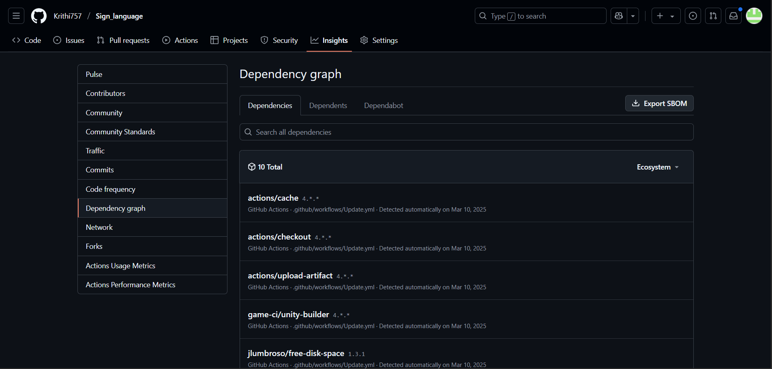

### **Deployments/ CI/ CD Pipeline**

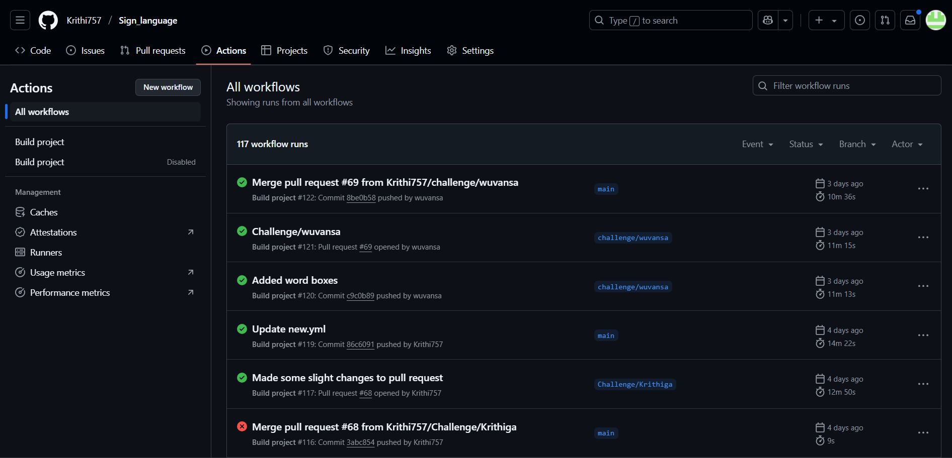

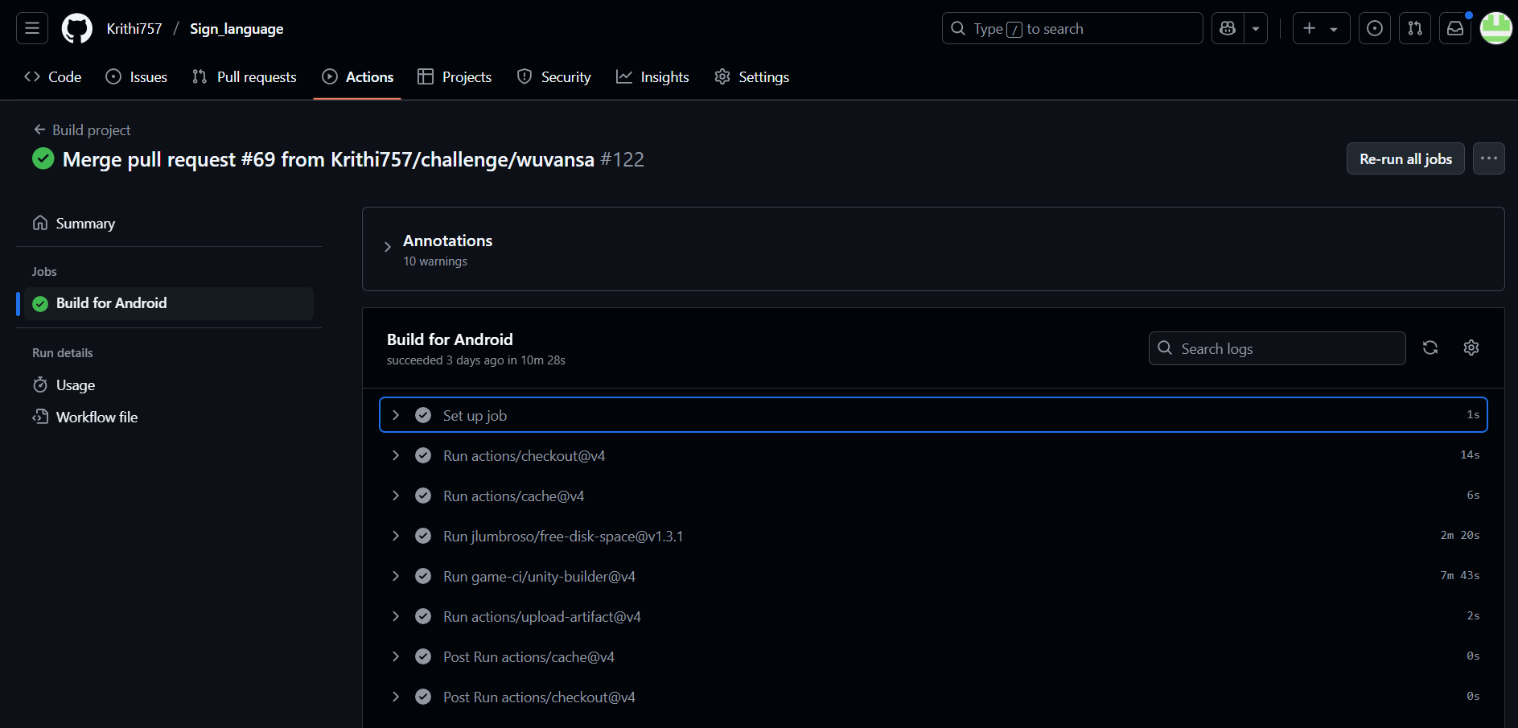

### **CRUD Operations**

#### **Member 1 (Imeth De Silva)**

#### **Member 2 (Krithiga Thachanamoorthy)**

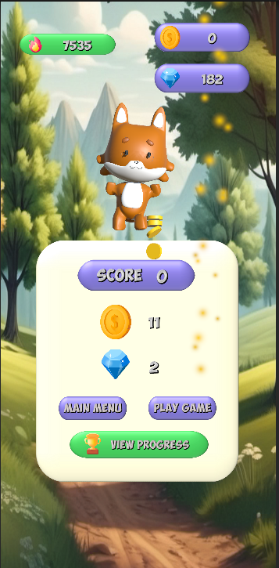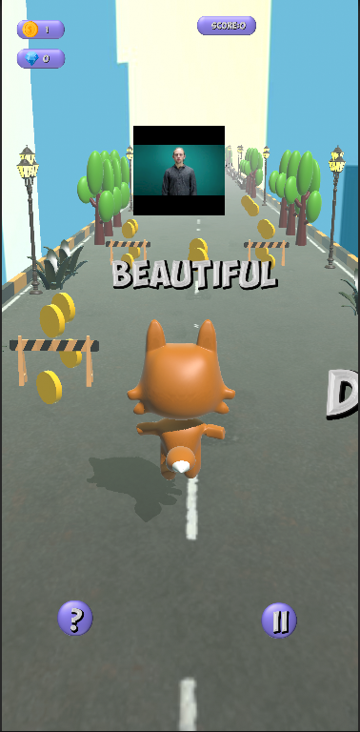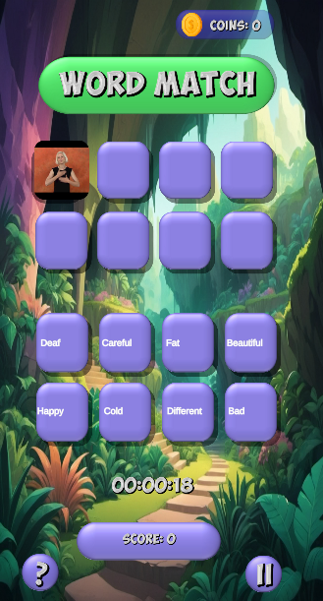

#### **Member 3 (Safiya Mahir)**

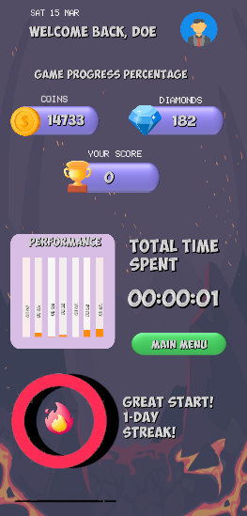

#### **Member 4 (Didula Aravinda)**

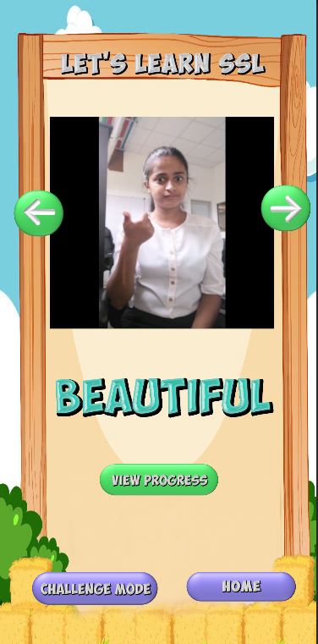

#### **Member 5 (Adnan Rauff)**

#### **Member 6 (Wuvansa Suraweera)**

## **Appendix Section B - Testing**

### **Appendix Section B.1 - Functional Requirements**

**B.1.1 FR1 - User selects a learning level**

| Test case no | Feature tested | Test case description | Test case condition | Expected result | Actual result | Status |
| --- | --- | --- | --- | --- | --- | --- |
| 1.0 | FR1: Learning Mode | User selects a learning level | User chooses a level to start learning | Level should load and user should see learning video and caption | Level loaded, and learning video played with caption | Pass |
| 1.0.1 | User should be able to view captions displayed under learning video | Captions should appear synchronized with video by default | Captions appear synchronized with video by default | Pass |
|  | | | | | | |
|

**B.1.2 FR2 - User chooses a challenge from the challenge menu**

| Test case no | Feature tested | Test case description | Test case condition | Expected result | Actual result | Status |
| --- | --- | --- | --- | --- | --- | --- |
| 2.0 | FR2: Challenge Mode | User chooses a challenge from the challenge menu | User starts the mini challenge to earn coins and diamonds | Game should load and user should be able to play | Game loads and player is able to play seamlessly without any lags | Pass |
|  | | | | | | |
|

**B.1.3 FR3 - Test tracking of user progress**

| Test case no | Feature tested | Test case description | Test case condition | Expected result | Actual result | Status |
| --- | --- | --- | --- | --- | --- | --- |
| 3.0 | FR3: Progress Tracking | Test tracking of user progress. | Display of charts based on user performance | User progress should be updated and displayed | Progress updated and displayed | Pass |
| 3.0.1 | The system tracks user progress from all modes | The system should display stars for all completed modes | The system displays stars for all completed modes | Pass |
| 3.0.2 | The system visualizes user performance. | Visualization in terms of charts | Visualization in terms of charts | Pass |
|  | | | | | | |
|

**B.1.4 FR4 -** Reward system validation

| Test case no | Feature tested | Test case description | Test case condition | Expected result | Actual result | Status |
| --- | --- | --- | --- | --- | --- | --- |
| 4.0 | FR4: Reward System | Reward system validation | Verify that rewards increase for correct answers and decrease for incorrect answers | Rewards should be updated correctly based on user performance | Rewards are correctly updated based in user performance | Pass |
|  | | | | | | |
|

**B.1.5 FR5 - Level based restriction**

| Test case no | Feature tested | Test case description | Test case condition | Expected result | Actual result | Status |
| --- | --- | --- | --- | --- | --- | --- |
| 5.0 | FR5: Level page | Level based restriction | Ensure users can only access content from selected levels | Users should be able to only access from the selected levels | Users are able to only access from the selected levels | Pass |
|  | | | | | | |
|

**B.1.6 FR6 - Challenge mode flexibility**

| Test case no | Feature tested | Test case description | Test case condition | Expected result | Actual result | Status |
| --- | --- | --- | --- | --- | --- | --- |
| 6.0 | FR6: Challenge Mode | Challenge mode flexibility | Ensure users can choose from a variety of challenges according to their desire | Users should be able to select a desired challenge from a challenge menu | Users are able to select a desired challenge from a challenge menu | Pass |
|  | | | | | | |
|

**B.1.7 FR7 - Adjust audio/ sound effect controls**

| Test case no | Feature tested | Test case description | Test case condition | Expected result | Actual result | Status |
| --- | --- | --- | --- | --- | --- | --- |
| 7.0 | FR7: Settings | Adjust audio/ sound effect controls | Test if users can adjust sound controls | Users should be able to able/disable music, sound effects separately or together | Users are able to able/disable music, sound effects separately or together | Pass |
|  | | | | | | |
|

**B.1.7 FR7 - Scene transition**

| Test case no | Feature tested | Test case description | Test case condition | Expected result | Actual result | Status |
| --- | --- | --- | --- | --- | --- | --- |
| 8.0 | FR8: Scene transition | Seamless scene transition | Test if user can go back to home page and go to the next scenes seamlessly | Users should be able to transition to the main menu when needed | Users are able to transition to the main menu when needed | Pass |
|  | | | | | | |
|

### **Appendix Section B.2 - Non-Functional Requirements**

**B.2.1 NFR1 - Reliability**

| Test case no | Feature tested | Test case description | Test case condition | Expected result | Actual result | Status |
| --- | --- | --- | --- | --- | --- | --- |
| TC01 | Reliability | Tested the system on a mobile phone. | Start the game and play for 1 hour and run without interruption. | The game should run without crashes or any significant lag | The game runs without crashes or any significant lag | Pass |
|  | | | | | | |
|

**B.2.2 NFR2 - Usability**

| Test case no | Feature tested | Test case description | Test case condition | Expected result | Actual result | Status |
| --- | --- | --- | --- | --- | --- | --- |
| TC02 | Usability | Tested the ease of transition between modes and UI readability. | User navigates from homepage to challenge mode. | Navigation should be seamless and the user reaches mode easily. | Navigation was seamless and the user reached mode easily. | Pass |
|  | | | | | | |
|

**B.2.3 NFR4 - Performance**

| Test case no | Feature tested | Test case description | Test case condition | Expected result | Actual result | Status |
| --- | --- | --- | --- | --- | --- | --- |
| TC03 | Performance | Test CPU and memory usage during gameplay with Unity Profiler Monitoring | Game is played for 10 minutes with continuous action | CPU usage remains below 80% and memory usage stays within optimal range. | CPU usage remains below 80% and memory usage stays within optimal range. | Pass |
|  | | | | | | |
|

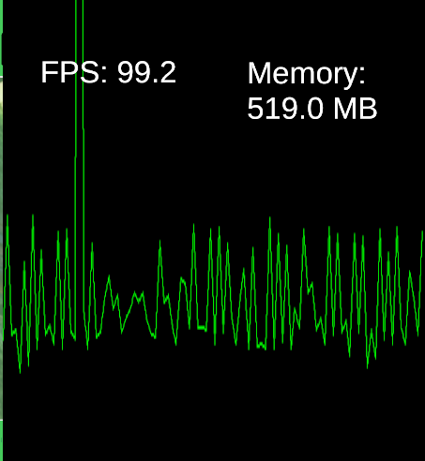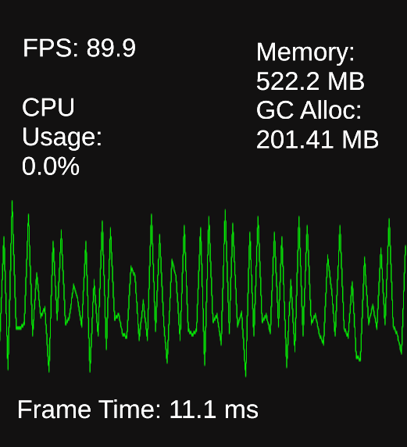

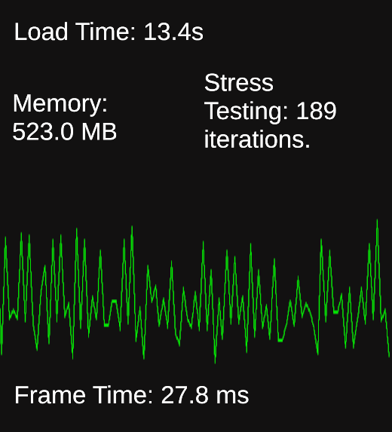

Additionally 3 other tests were conducted in Unity, where performance metrics such as FPS rate, memory load, and frame time were recorded under different stress-loading conditions. These tests were visualized using plot graphs to analyze variations over time. The results indicate a gradual decline in FPS from 99.2 to 89.9, suggesting an increasing computational load. Memory usage remained relatively stable fluctuating between 519 MB and 522 MB, while GC allocation was recorded at 201.41 MB. Frame time slightly increased from 10.9 ms 11.1 ms reflecting minor delays in rendering performance. The CPU usage remained at 0.0% during these tests, which could indicate GPU-intensive processes or idle CPU conditions.

### **Appendix Section B.3 - Unit Testing**

To maintain reliability and accuracy of core gameplay mechanics, rigorous unit testing was conducted using Unity’s NUnit Framework.

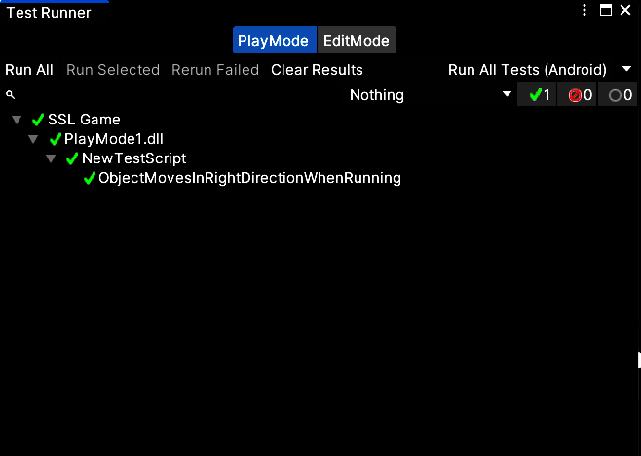

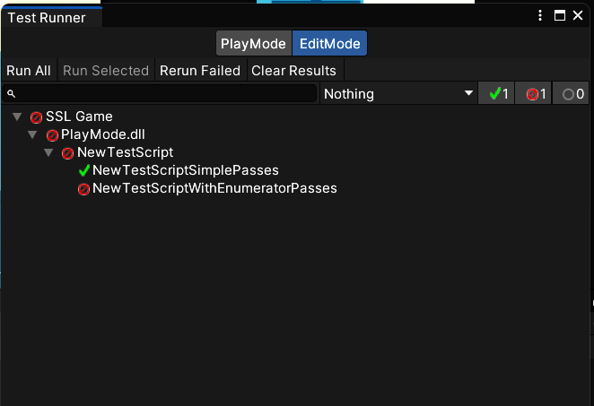

The tests focused on validating essential interactions such as player movement, jumping mechanisms, health restoration and touch-based inputs. Early test runs revealed a mix of successful and failed cases, pinpointing specific areas that required refinement. Through iterative debugging and improvements, all critical tests were successfully passed, demonstrating enhanced system stability.

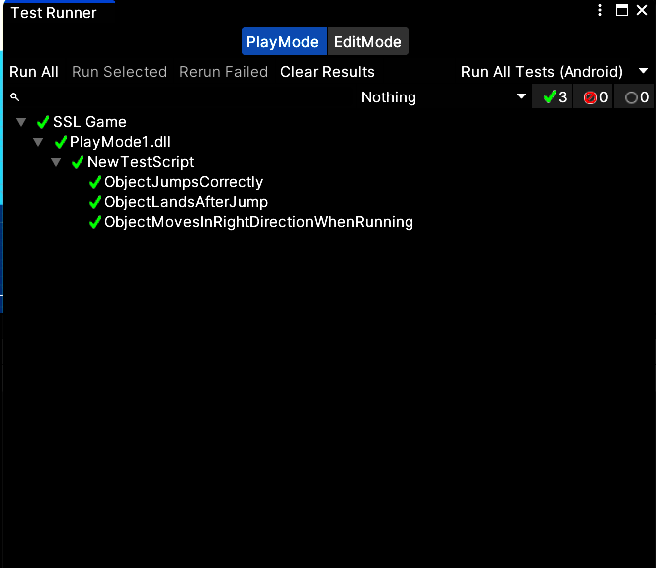

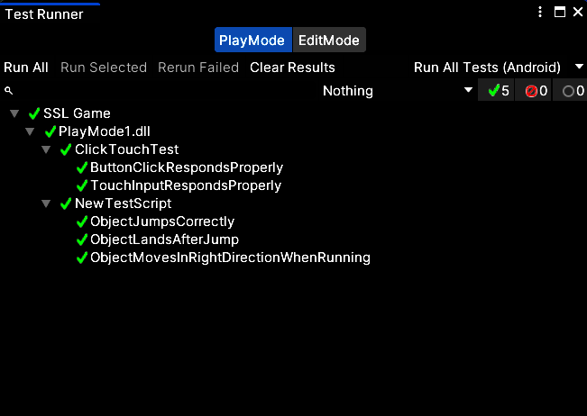

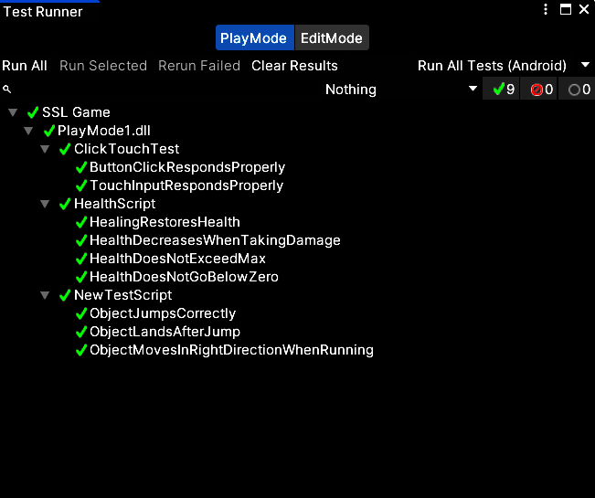

The test suite covered multiple game aspects. Movement-related tests ensure precise motion using Unity’s Character Controller, verifying expected position changes. Health mechanisms were validated with cases ensuring that damage and healing systems function correctly. Additionally, input based tests confirmed the responsiveness of in-game controls.

Additionally, these tests provided confidence in the stability and accuracy of the game’s core mechanics, laying a solid foundation for further development of the SSL learning features.

### **Appendix Section B.4 - Usability Testing**

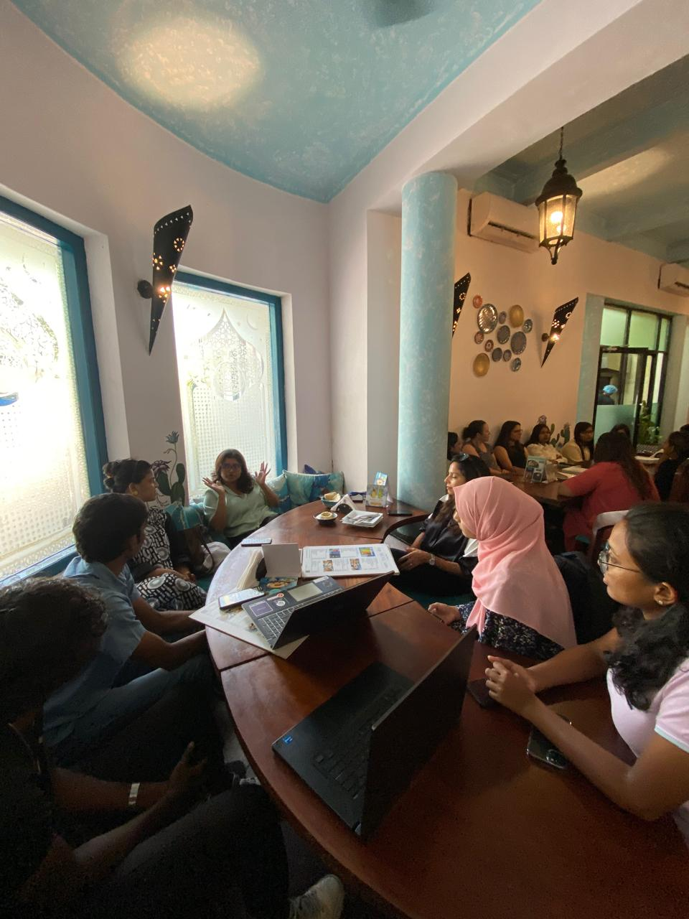

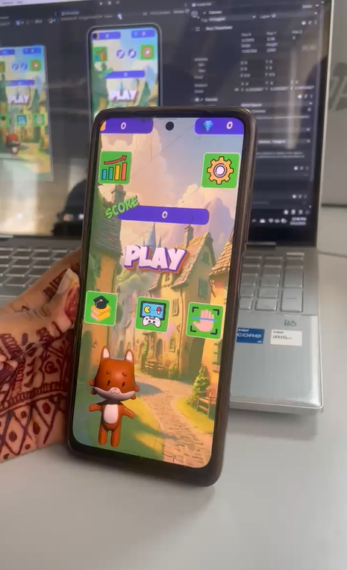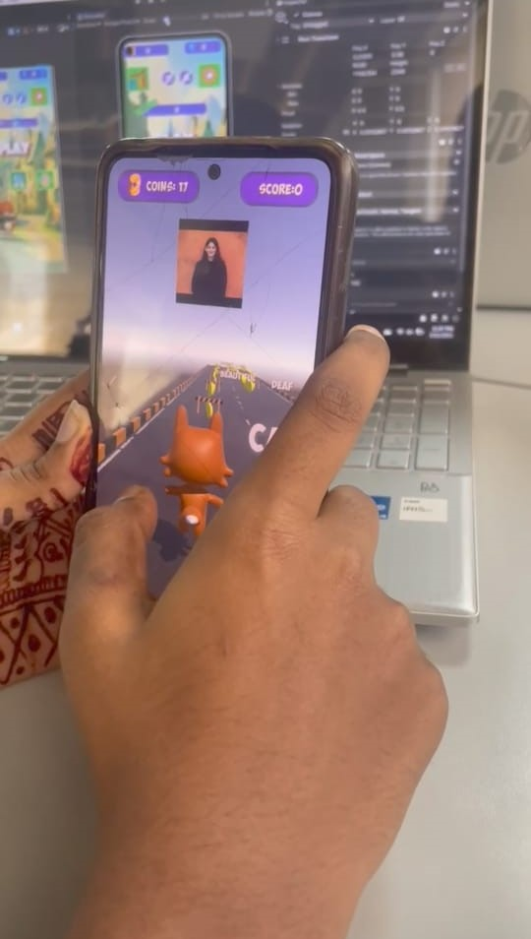

### **Appendix Section B.5 - Compatibility Testing**

## **Appendix Section C - Evaluation**

## **Appendix Section C.1 - Meeting with the Principal of the Ratmalana School for the Deaf**

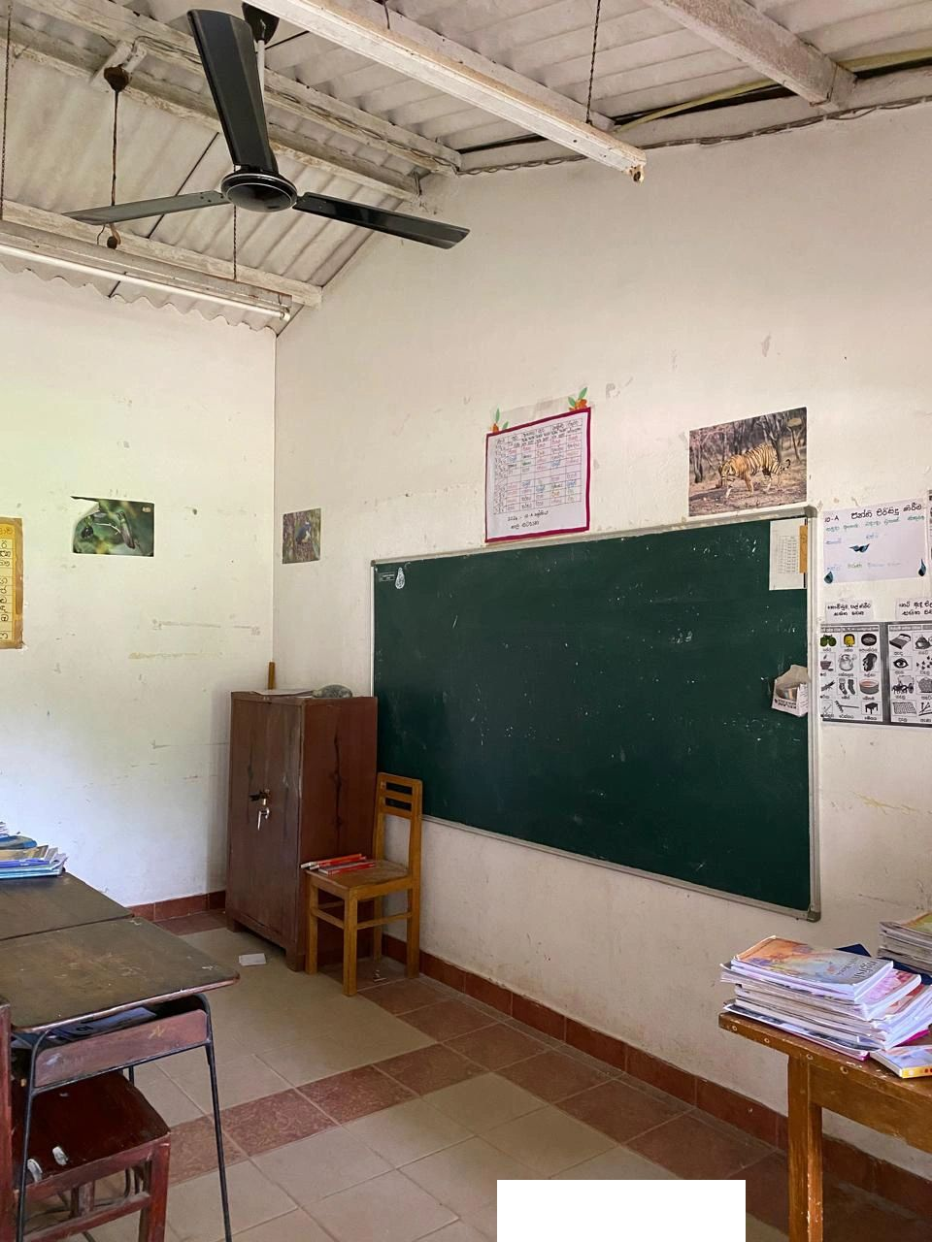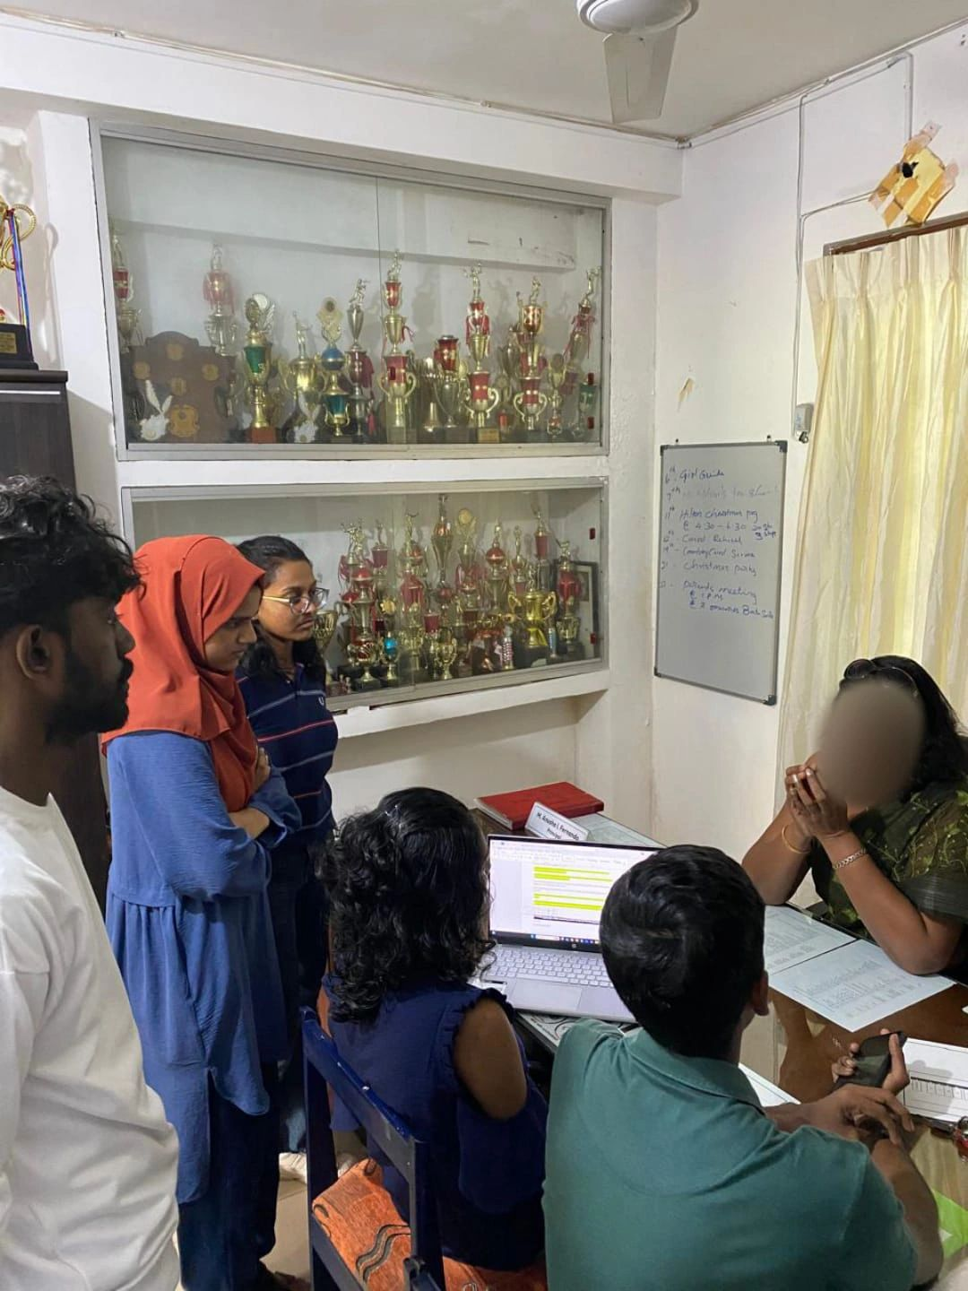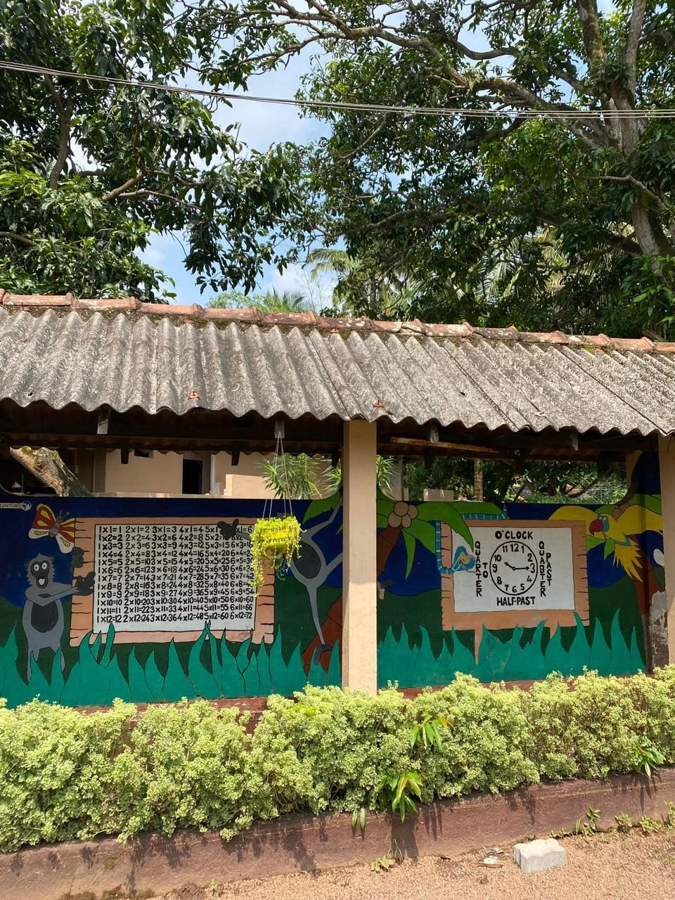

### **Appendix Section C.2 - Meeting with Senior Speech Therapists**

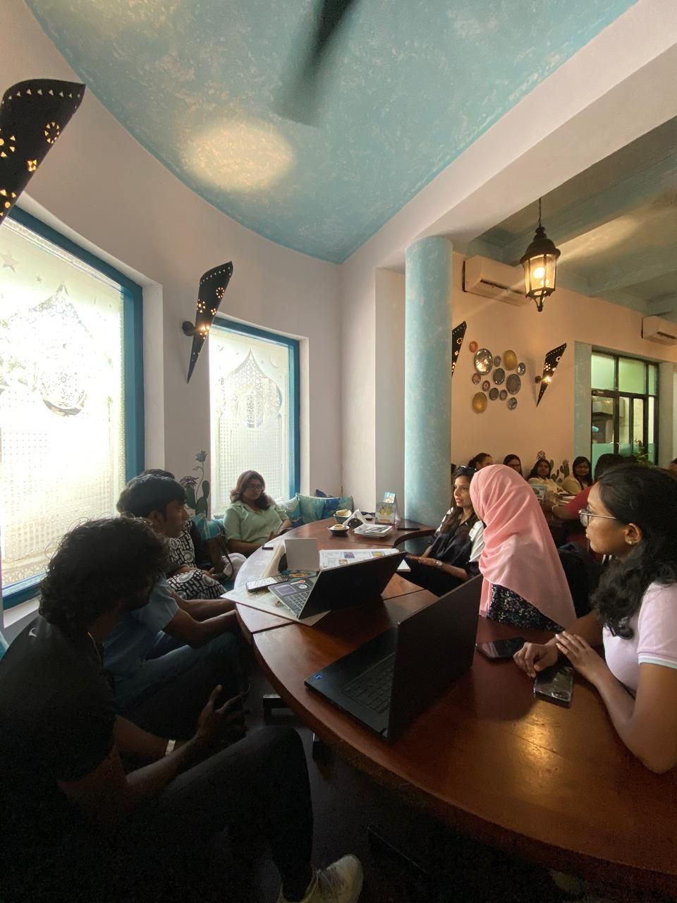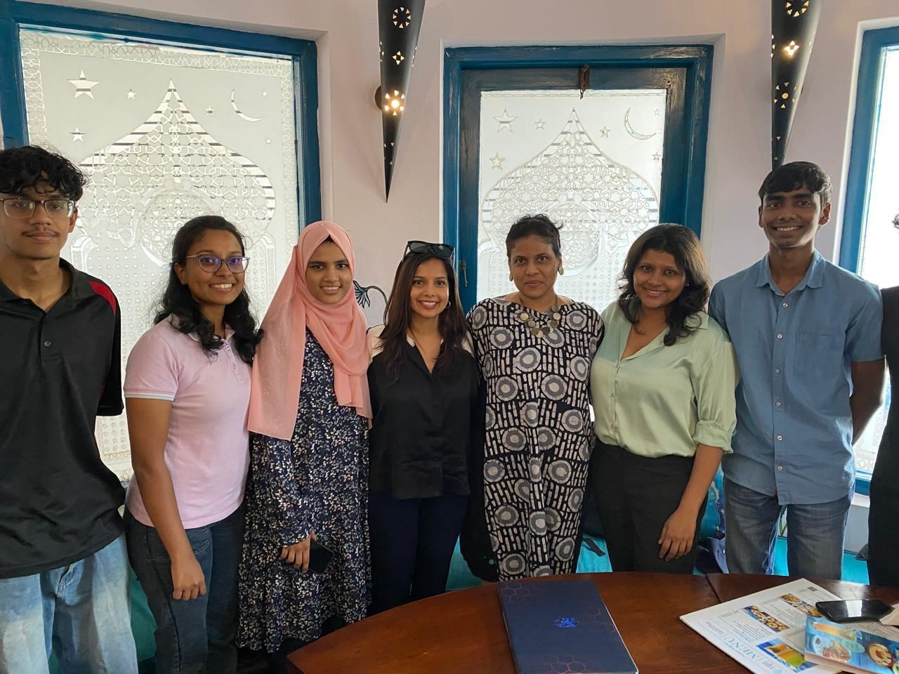

### **Appendix Section C.3 - Meeting with Child & Adolescent Psychiatrist**

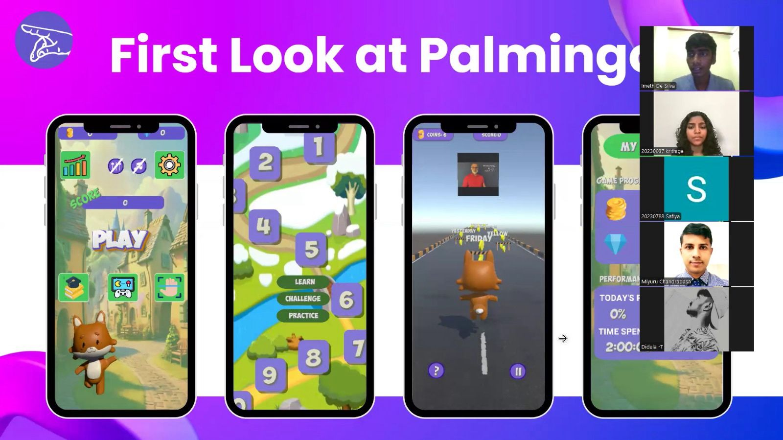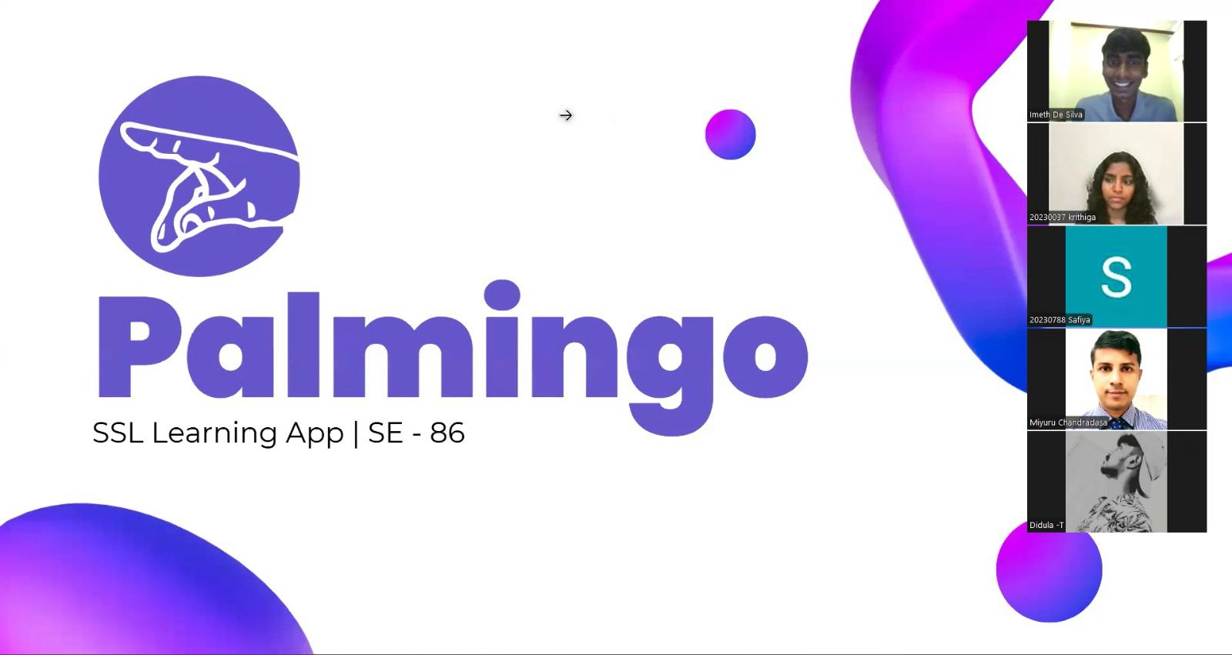

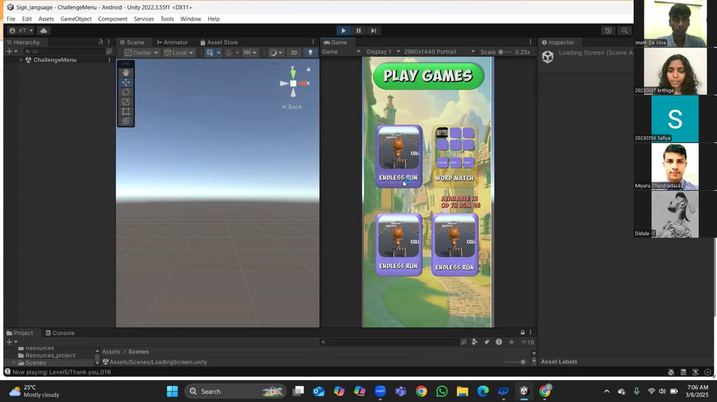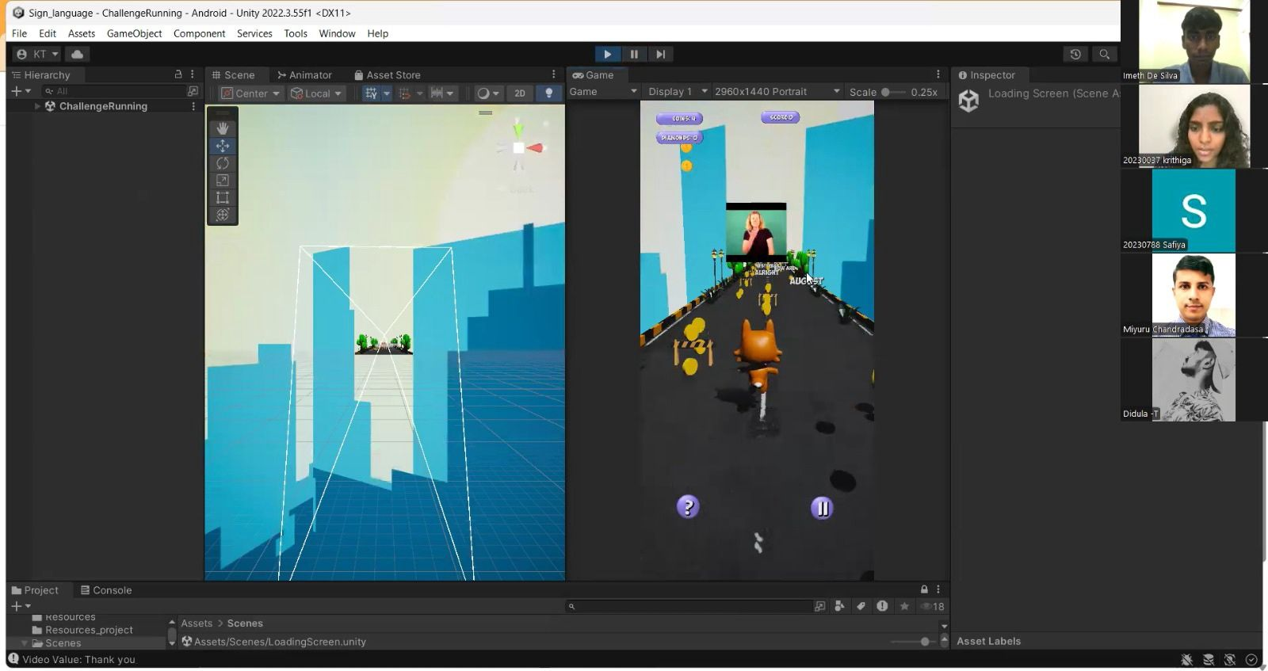

## **Appendix Section D - Conclusion**

### **Appendix Section D.1 - Extra Work (Competition, Research Paper)**

